Group Project Documentation   
Building Cross-Platform Back-End Application With .NET

BMOS - Bird meal order system

**Prepared by Group 1**

***Thái Quốc Toàn – SE151272  
Lê Xuân Bách – SE150031  
Lê Hồng Thành – SE150023  
Trần Minh Thuận – SE150124***

**Ho Chi Minh City, 2023**

**Table of Contents**

**Table of Contents ii**

**Revision History ii**

**1.** **Project Introduction 1**

1.1 Product Perspective 1

1.2 User Classes and Characteristics 1

**2.** **Database Design 1**

**3.** **System Architecture 1**

**4.** **Implementation 2**

4.1. Deployment Considerations 2

4.2. Screenshots and explanations 2

**Revision History**

|  |  |  |  |
| --- | --- | --- | --- |
| **Name** | **Date** | **Reason For Changes** | **Version** |
| *Group 1* | *20/5/2023* | *Product Perspective, User Classes and Characteristics* | *1.0* |
| *Group 1* | *23/5/2023* | *Workflows, Class Diagram* | *1.1* |
| *Group 1* | *30/5/2023* | *Physical database and System Architecture* | *1.2* |
| *Group 1* | *22/6/2023* | *Update System Architecture* | *1.3* |
| *Group 1* | *30/6/2023* | *Implementation / Deployment Consideration* | *1.4* |
| *Group 1* | *6/7/2023* | *Implementation / Screenshots and explanations* | *1.5* |

# Project Introduction

## Product Perspective

BMOS is a system that provides an online bird meal ordering service for a store. The system will allow stores' staff to create suitable meals for each type of bird and these meals will be validated before being sold to customers by the shop owner then these meals will be are sold to customers according to the order they have placed and confirmed on the BMOS system.

This system is organized according to the model of selling product combos based on the recipe of the bird meal. This model will be different from the selling-by-product model, where the product that is delivered to the customer is the product that is processed after the system has received the customer's order and is confirmed by the staff at the store on the system. Each recipe will be verified and confirmed by the store owner before being put on the display system or after being updated by the staff with the details of the product, it must also be confirmed through the store owner, the product that is allowed to be sold on the system.

## User Classes and Characteristics

In the system there are 3 roles that are allowed to use as follows:

* Customer
  + Manage Profile
    - View profile
    - Update profile
  + View list of meals
    - View meal details
    - View products of meals
    - View products details
  + Add/Remove meals to/from cart
  + Checkout
  + View history Orders
  + Deposit to Wallet With MoMo
  + View Wallet Transaction
  + View Balance of Wallet
* Staff
  + View dashboard
  + Manage meals
    - View list of meals
      * View meal details
    - Create a new meal
    - Update a meal
    - Delete a meal
  + Manage Orders
    - View list of orders
      * View Order details
    - Confirm order after customer checkout successfully.
    - Change status after the meal comparation have finished.
  + Manage products
    - View List Products
      * View Product Detail
    - Create a new product
    - Update a product
    - Delete a product
* Store Owner
  + View dashboard
  + Manage customer accounts
    - View list of customer account
      * View customer account details
      * Ban customer account
  + Manage staff accounts
    - Create a new staff accounts
    - View list of staff accounts
      * View staff account details
    - Delete staff account
    - Update Staff Account
  + View Balance of Wallet
  + View Wallet Transactions
* System Handler
  + Automatically check expired products
  + Automatically check expired meals
  + Automatically check wallet transaction status
  + Automatically check New Order that is more than 3 days from an ordered date

## Workflows

* ***Workflow 1***: Store Owner -> (1) Login -> (2) Create Account Staff -> Staff -> (3) View Staff Accounts -> (4) Create New Product -> (5) View List Products -> (6) Create new Meal --> (7) View List Meals.
* ***Workflow 2***: Guest -> (1) Register -> Become a new customer -> (2) Login -> (3) Add Meal to Cart -> Checkout -> Error Balance is not enough -> (4) Deposit to Wallet With MoMo -> Show Page Deposite Success/Failed -> (5) Create Wallet Transaction -> (6) View Balance of Wallet -> (7) View Wallet Transaction.
* ***Workflow 3***: Customer -> (1) Login -> (2) view, search meal -> (3) add to cart -> (4) checkout -> (5) View History Orders-> (6) View Order Detail -> Staff -> (7) Login -> (8) View Orders -> (9) Confirm To Processing -> Customer -> (10) View History Orders -> Staff -> (11) Confirm To Done -> Customer -> (12) View History Orders -> (13) View Wallet -> (14) Store Owner -> (15) Login -> (16) View Balance of Wallet.
* ***Workflow 4***: Customer -> (1) Login -> (2) Add Meal To Card -> (3) Checkout -> (4) View History Orders -> (5) View Order Detail -> (6) Cancel Order -> (7) View Balance of Wallet -> (8) View Wallet Transaction -> Store Owner -> (9) Login -> (10) View Balance of Wallet.

# Database Design

2.1 Class Diagram

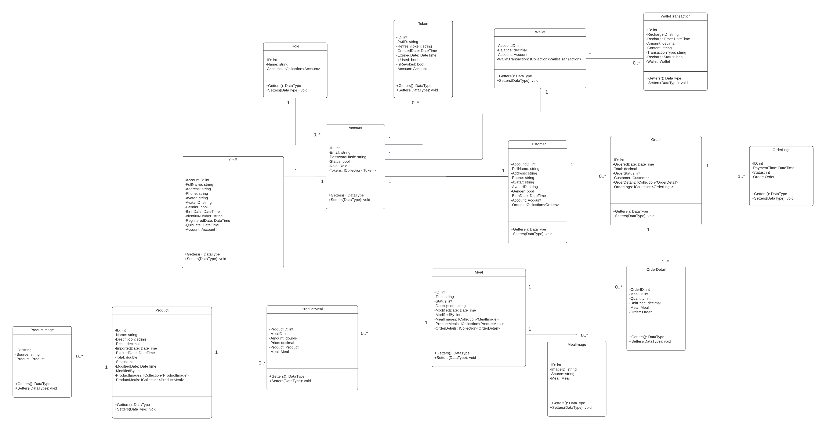

2.2 Physical Database



# System Architecture

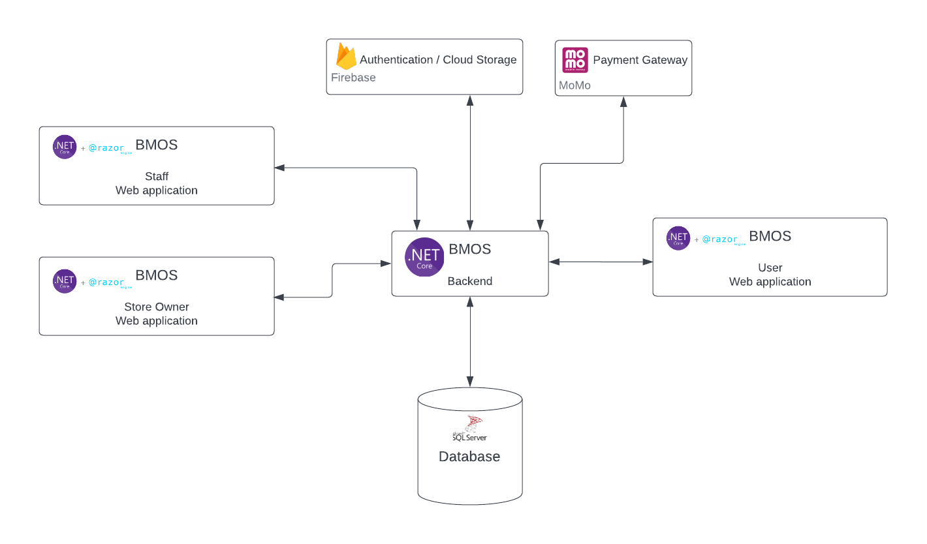

# Implementation

## Deployment Considerations

4.1.1 Software Requirement

1. Dotnet SDK 6: <https://dotnet.microsoft.com/en-us/download/dotnet/6.0>
2. Visual Studio: <https://visualstudio.microsoft.com/vs/>
3. SQL Server Managerment System: <https://learn.microsoft.com/en-us/sql/ssms/download-sql-server-management-studio-ssms?view=sql-server-ver16>

4.1.2 Setup Files

1. BMOS.Group1.sql: Database scripts for BMOS system.
2. BMOS.Group1.WebApplication.zip: API for BMOS system contains:
   1. BMOS.BAL
   2. BMOS.DAL
   3. BMOS.WebAPI
   4. BMOS.WebClient
   5. BMOS.WebClient.Store

4.1.3 Installation Instruction

4.1.3.1 Setup database

a. Download and install SQL Server Management System follow these guidelines: <https://learn.microsoft.com/en-us/sql/ssms/download-sql-server-management-studio-ssms?view=sql-server-ver16>

b. Run SQL Script

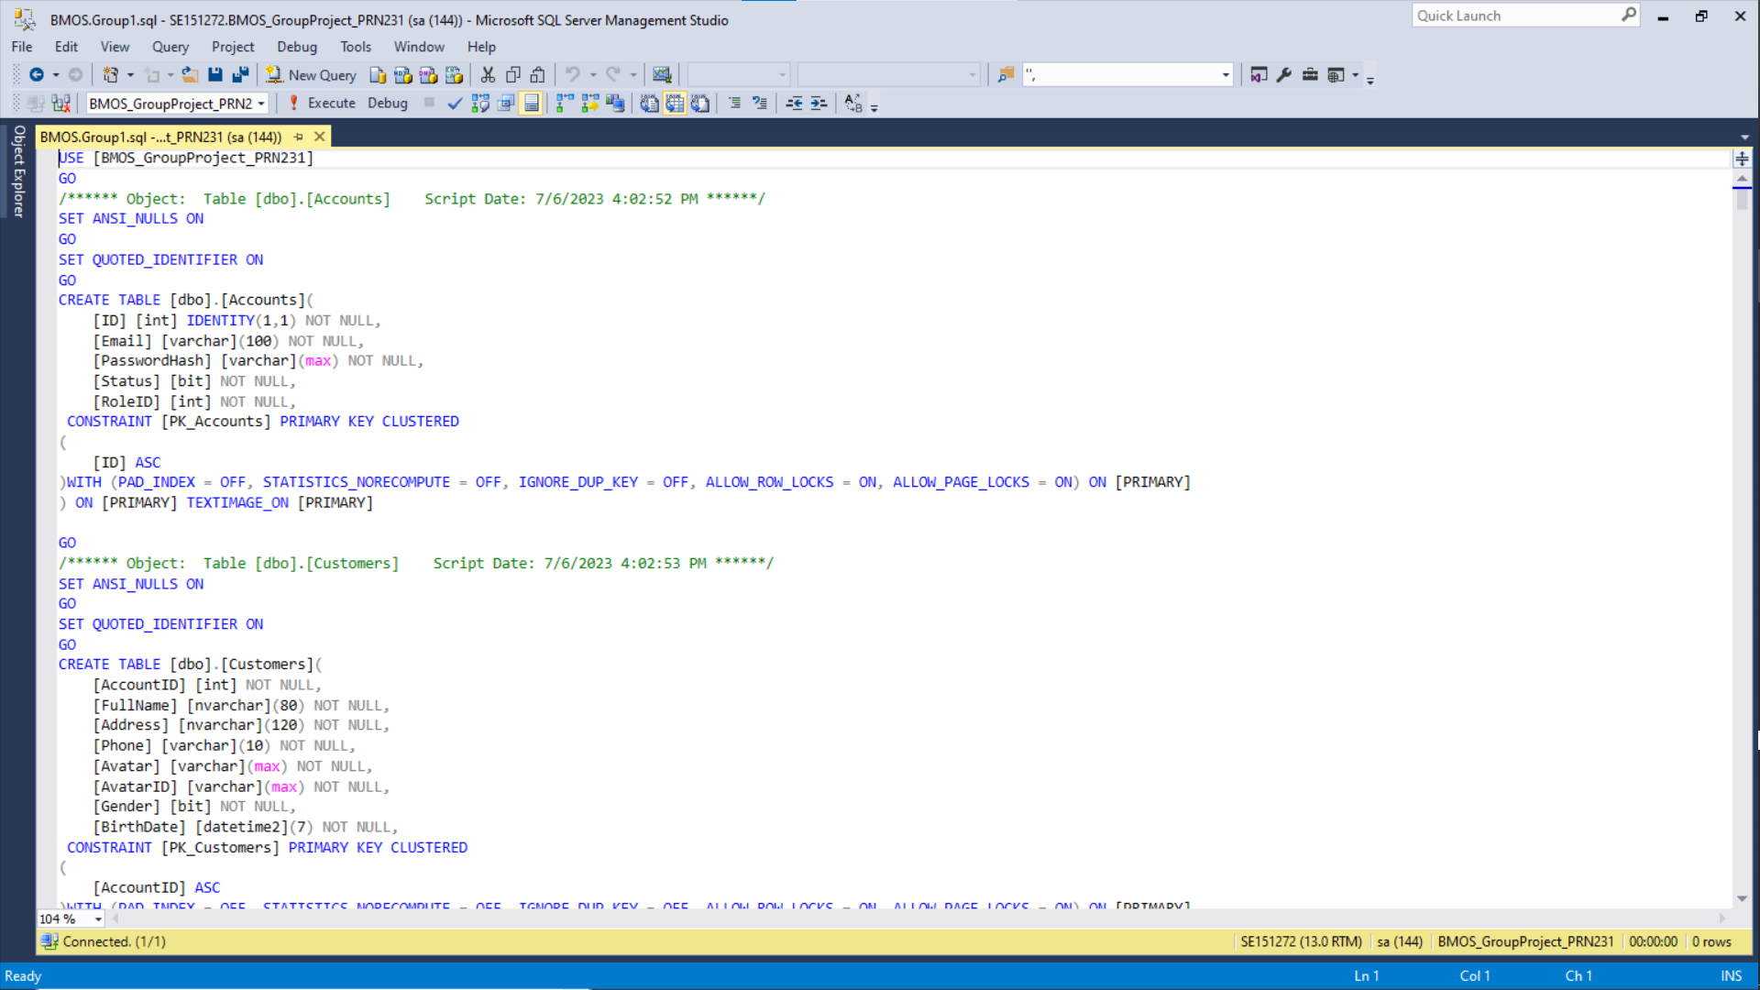

4.1.3.2 Setup local backend API

a. Download and install Visual Studio follow these guidelines:

<https://visualstudio.microsoft.com/vs/>

b. Run Visual Studio and Open appsettings.json in BMOS.WebAPI

* Modify ConnectionStrings to match with your local, Uid (username), Pwd (password)

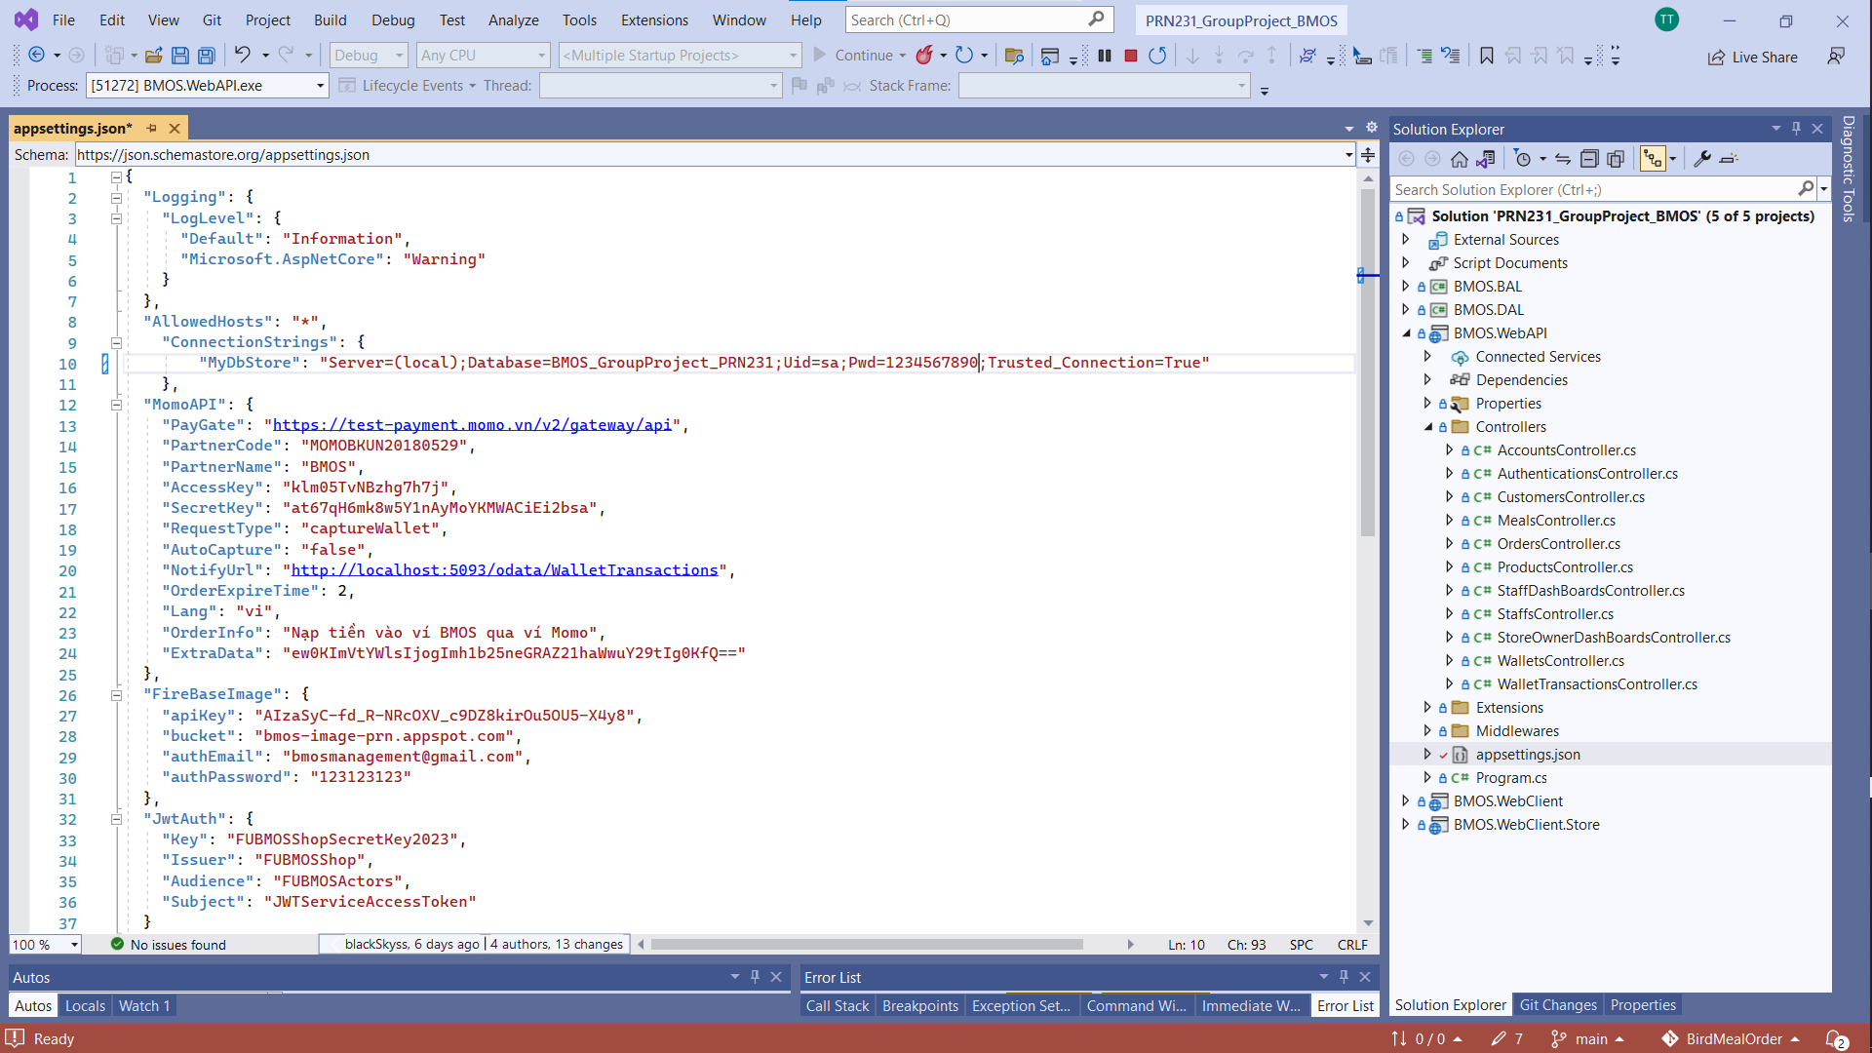

c. Config Startup Projects with multiplt startup projects

* BMOS.WebAPI, BMOS.WebClient, BMOS.WebClient.Store

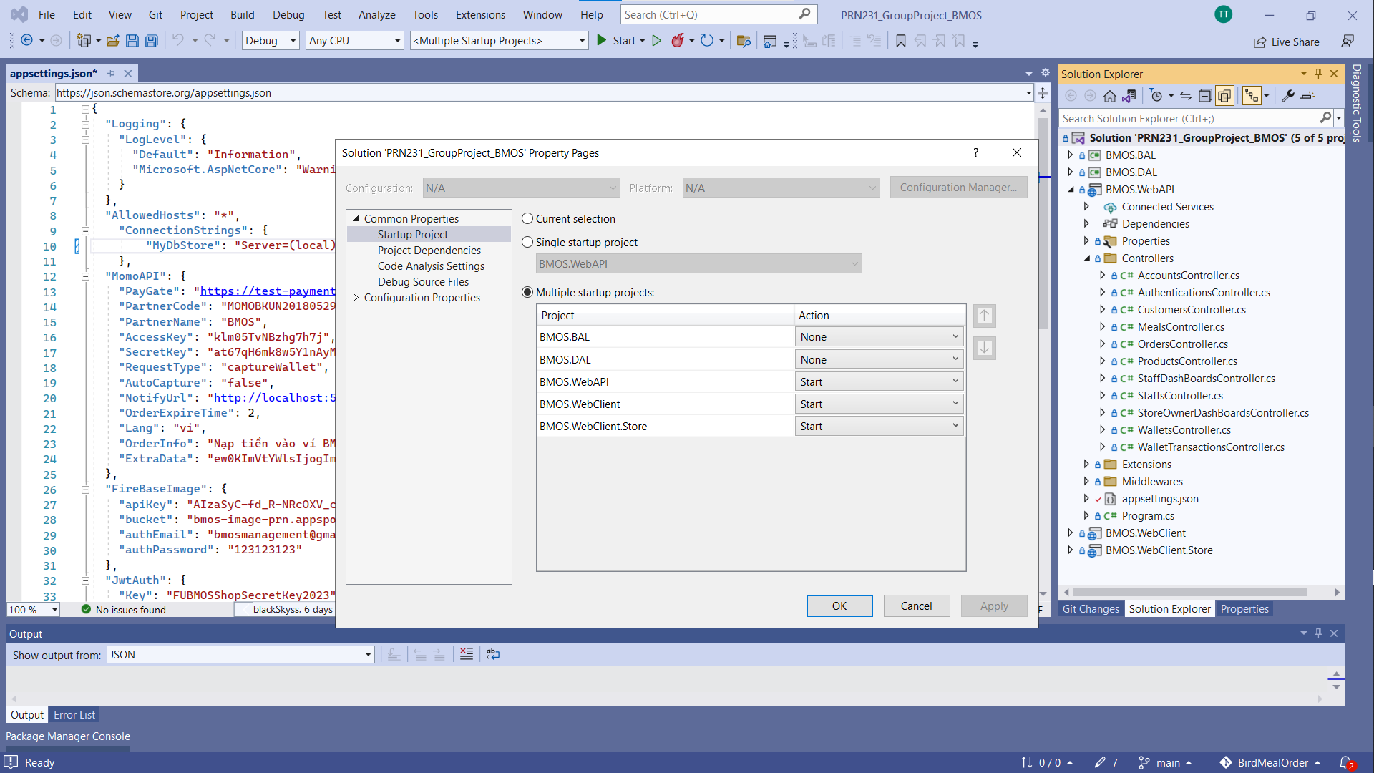

## Screenshots and explanations

4.2.1 Application Usage

4.2.1.1 Web application for customer usage:

**<Guest> Landing Page, Bird Foods Page, Bird Food Page, Bird Meals Page, Bird Meal Page, Cart Page**

Action 1: Guest open BMOS web application, the landing page will be shown.

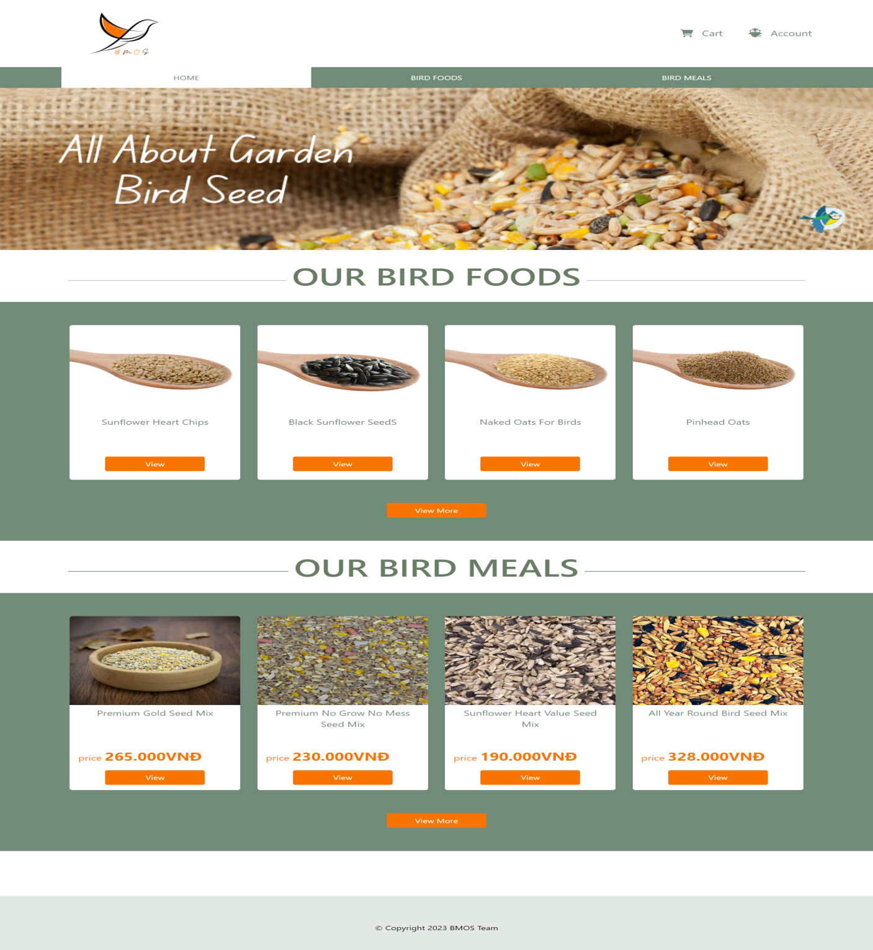

Action 2: Guest click on [Account] hyperlink to go to Login page and ckick on [Register Now] hyperlink to go to Register page.

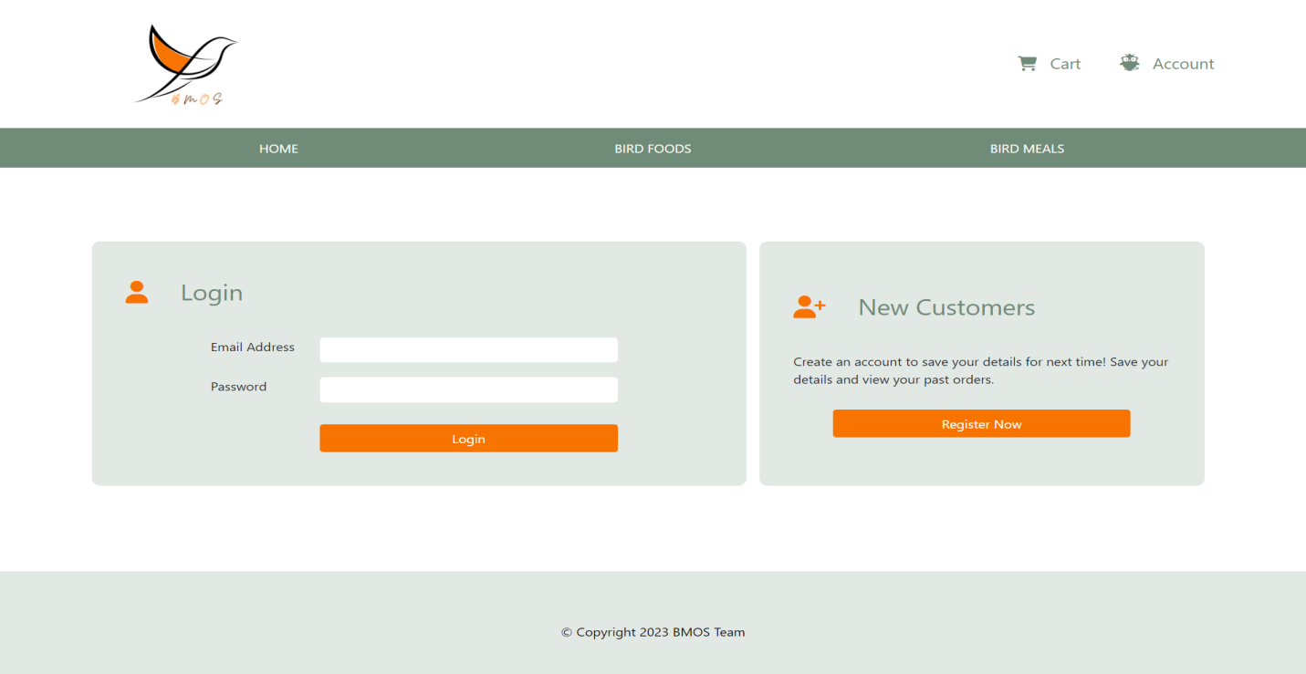

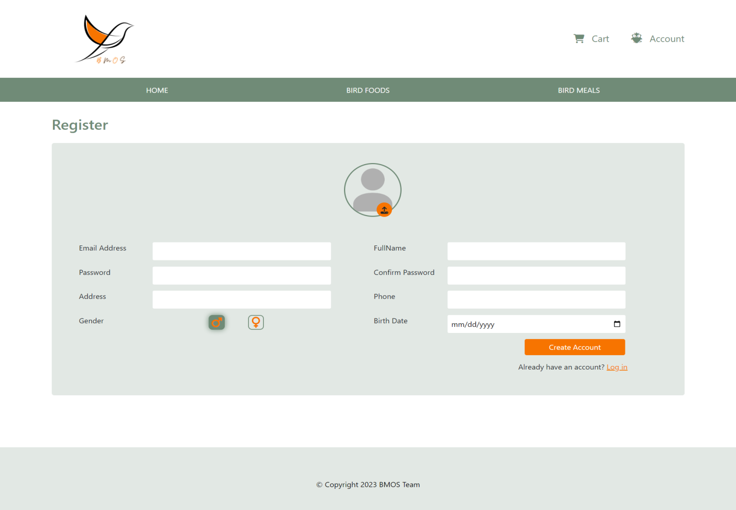

Action 3: Guest can view Bird Foods/Bird Food Detail and Bird Meals/Bird Meal Detail

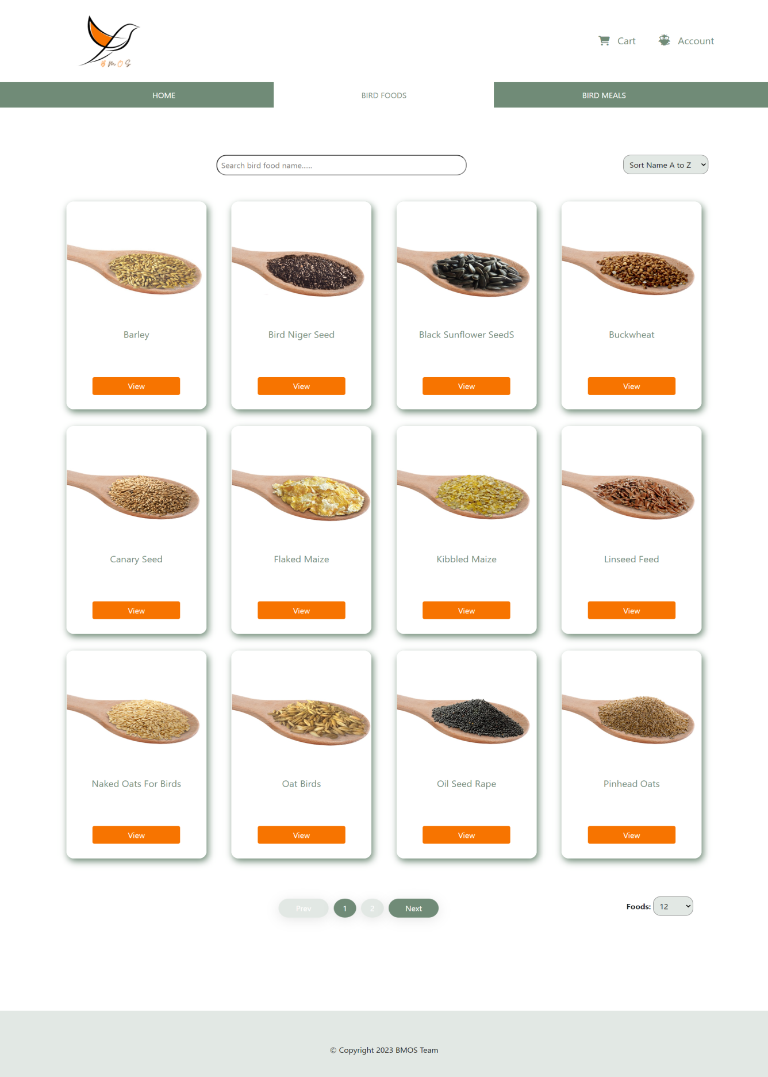

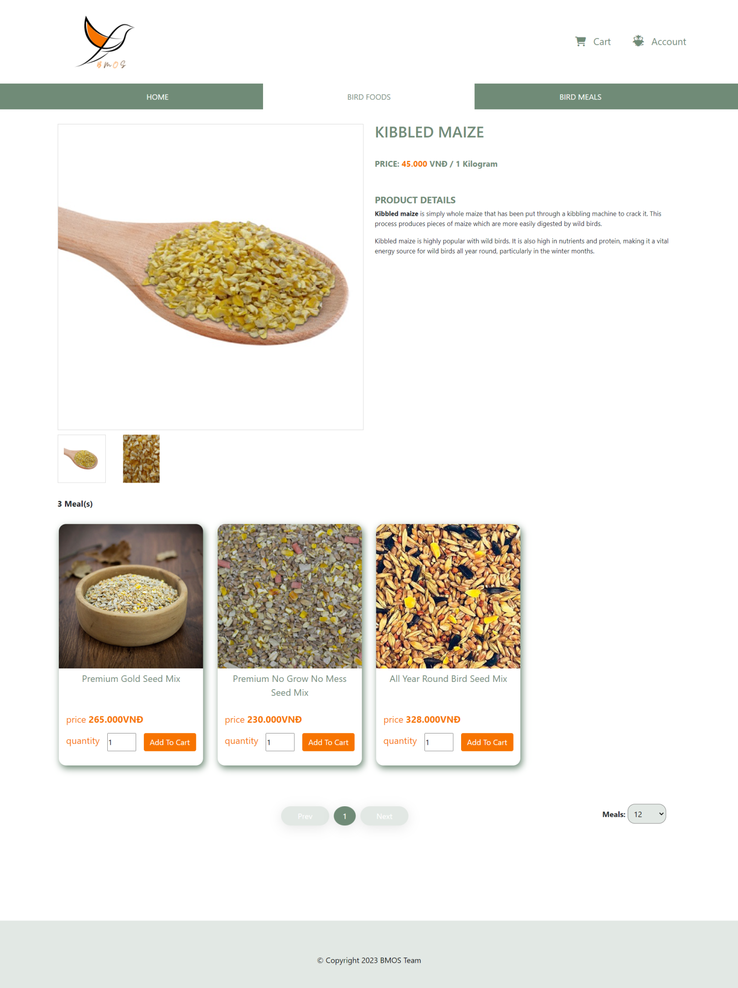

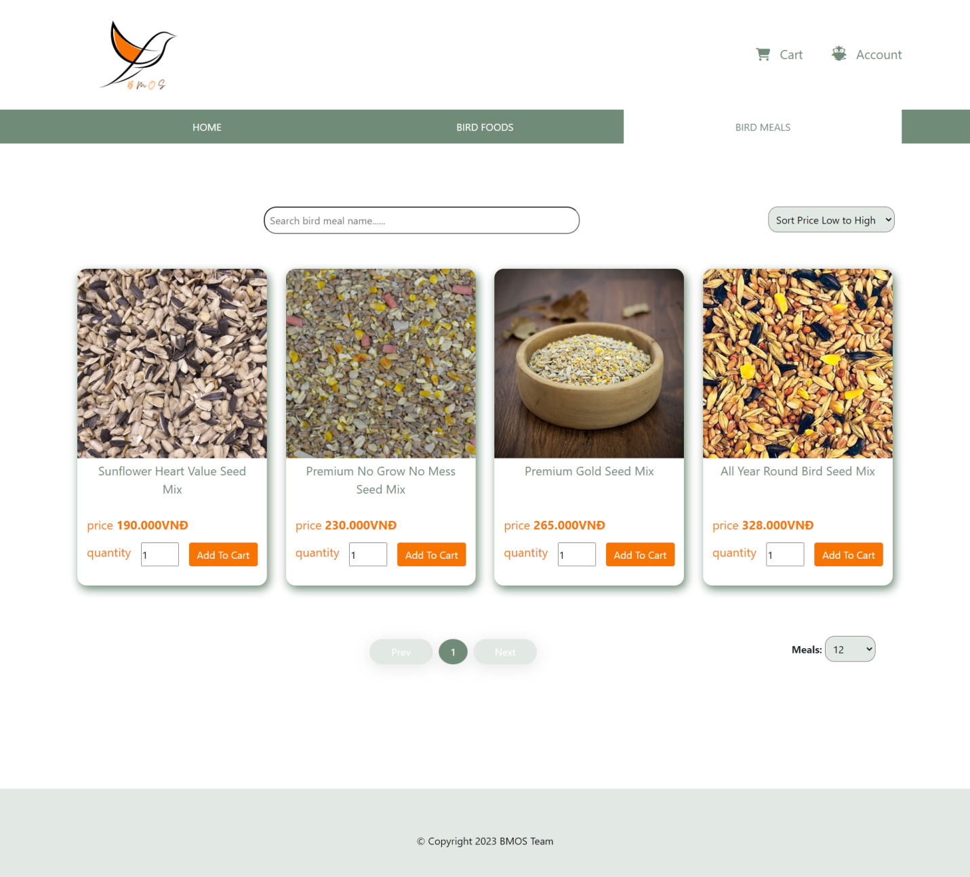

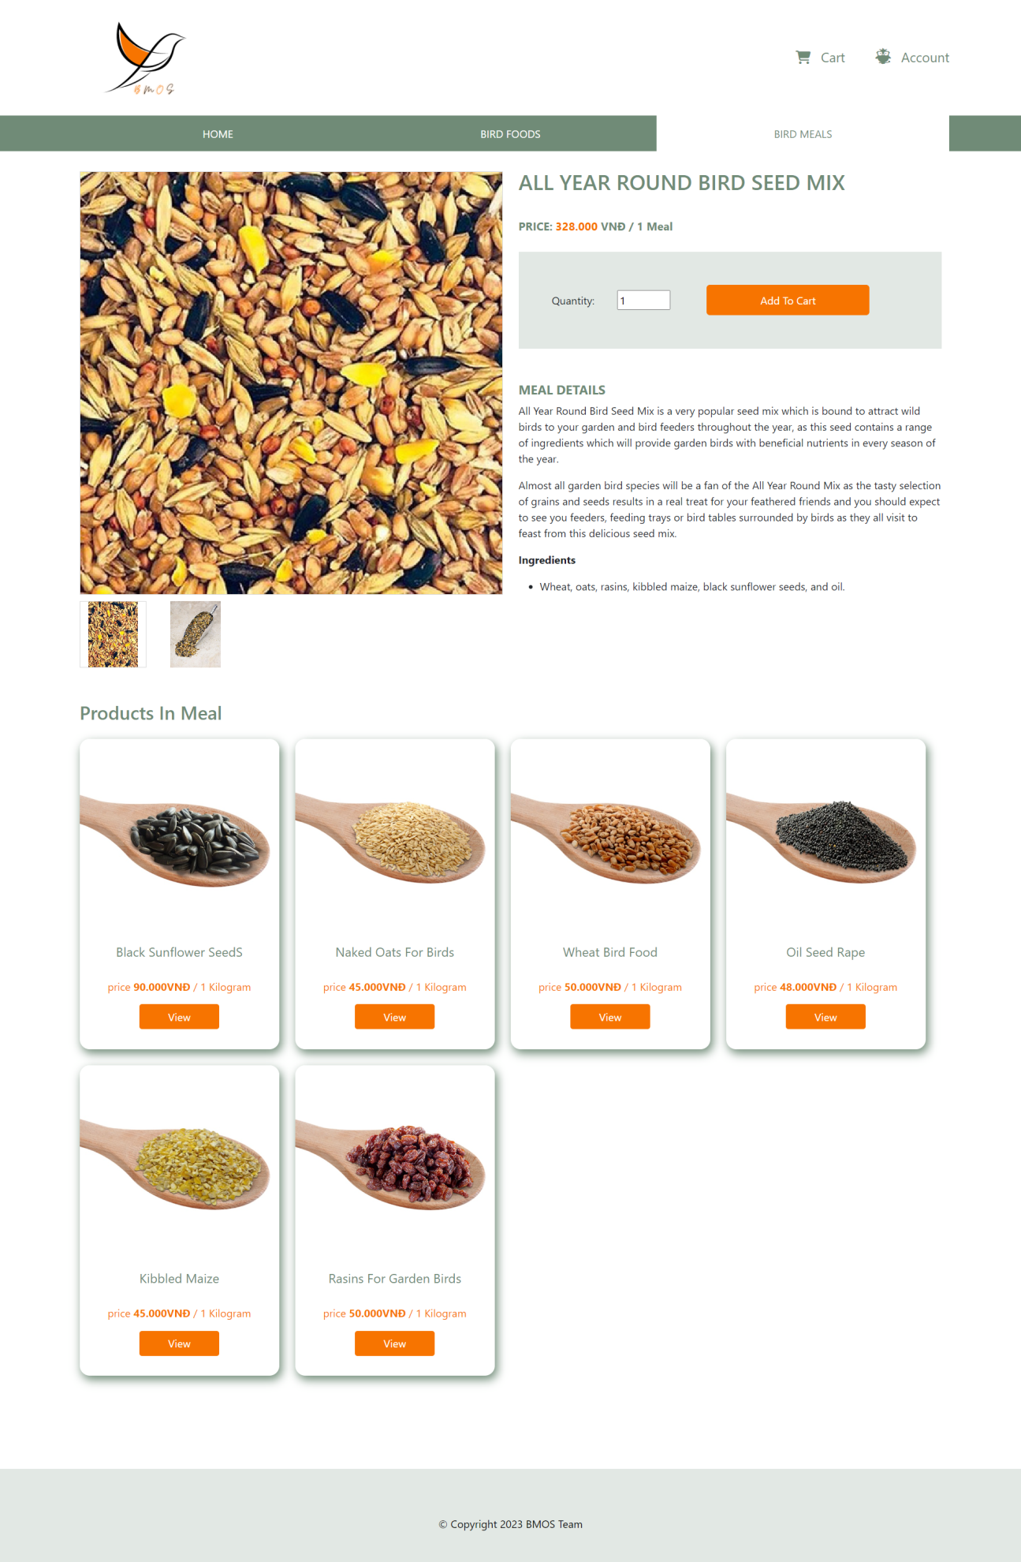

Action 4: Guest can add meals to card but they can not checkout for these meals if they did not login with **Customer** Role.

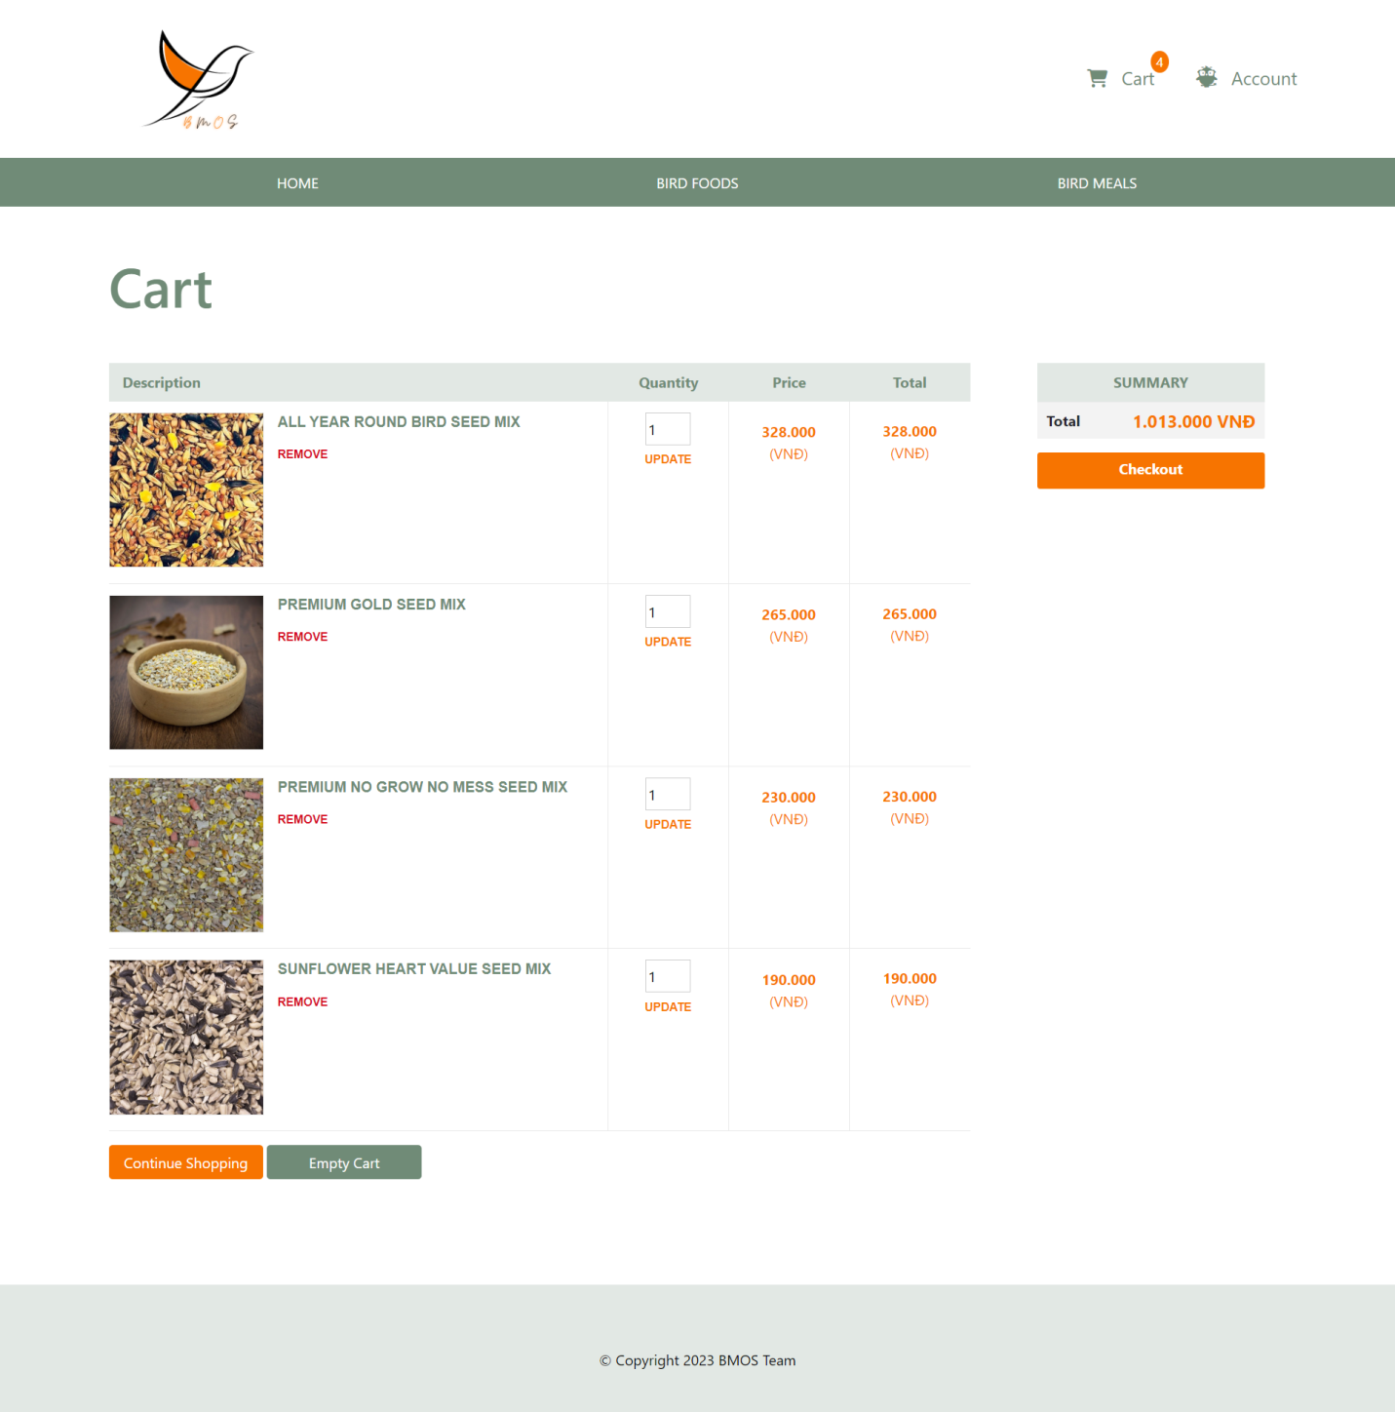

**<Customer> Profile Page, Update Profile Page, Wallet Page, History Orders Page, History Order Page**

Action 1: Customer clicks [Profile] hyperlinl to go to Profile Page and Customer clicks [Update] hyperlink to go to Update Profile Page.

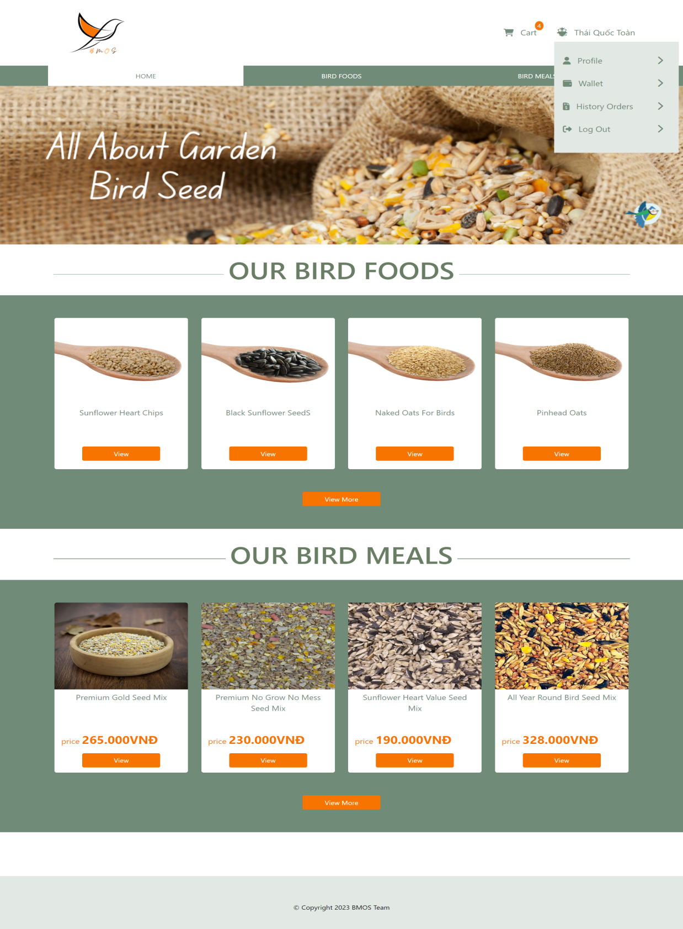

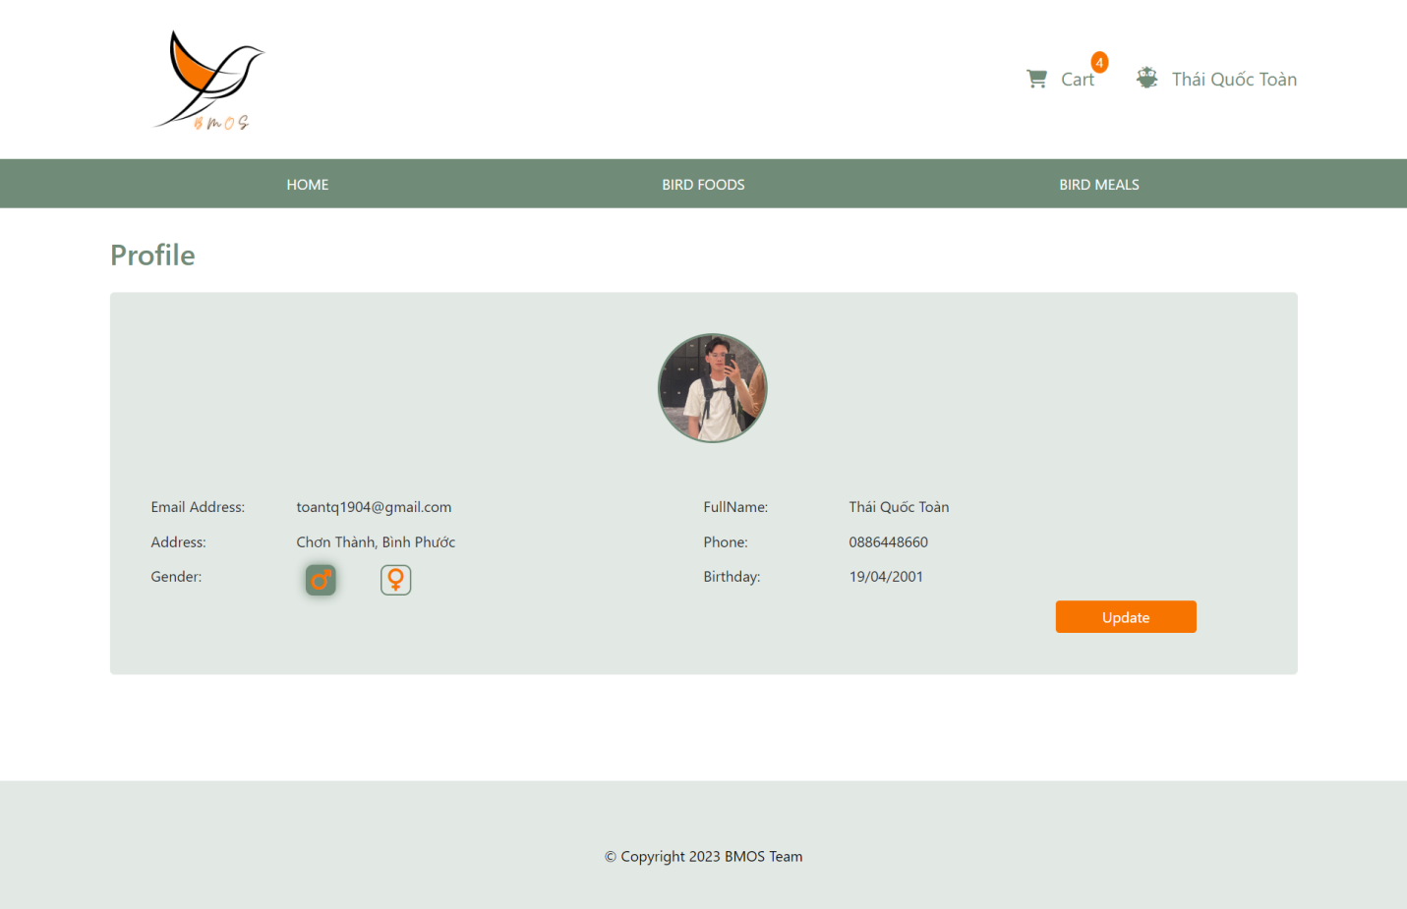

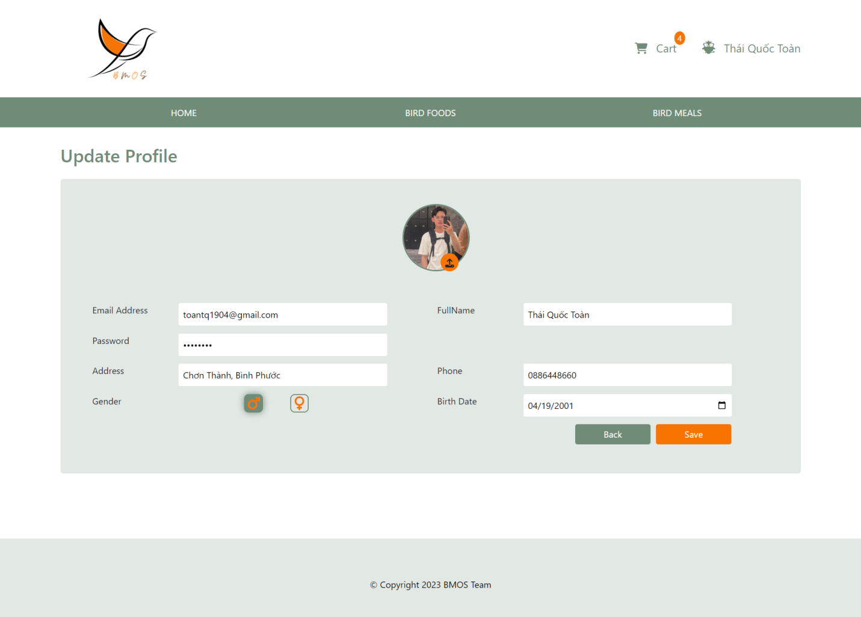

Action 2: Customer clicks [Wallet] hyperlink to go to Wallet page.

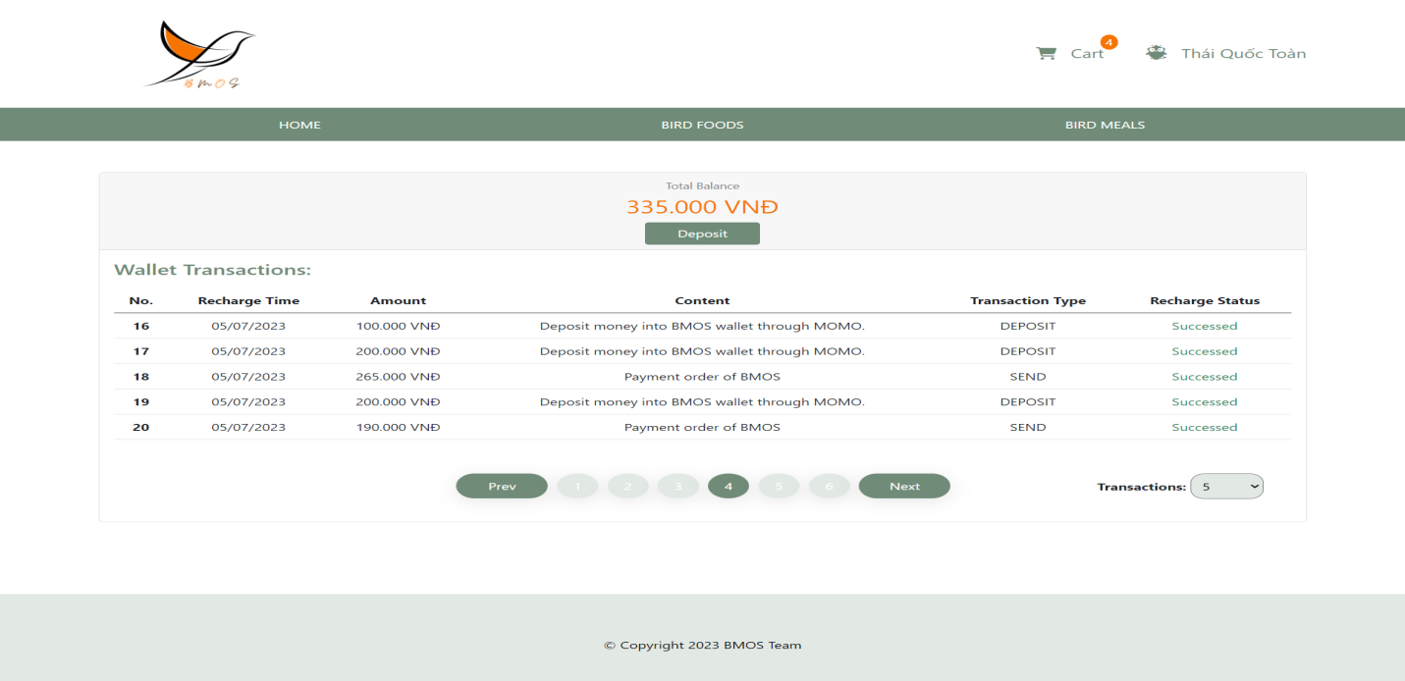

Action 3: Customer clicks on [Deposit] button to popup model that helps customer can input amount of money that they want to deposit to BMOS wallet with MoMo Payment Gate.

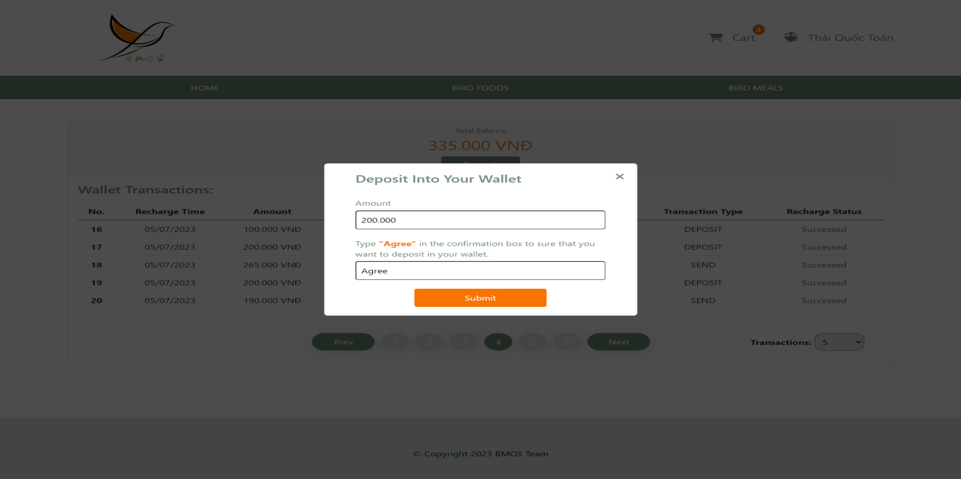

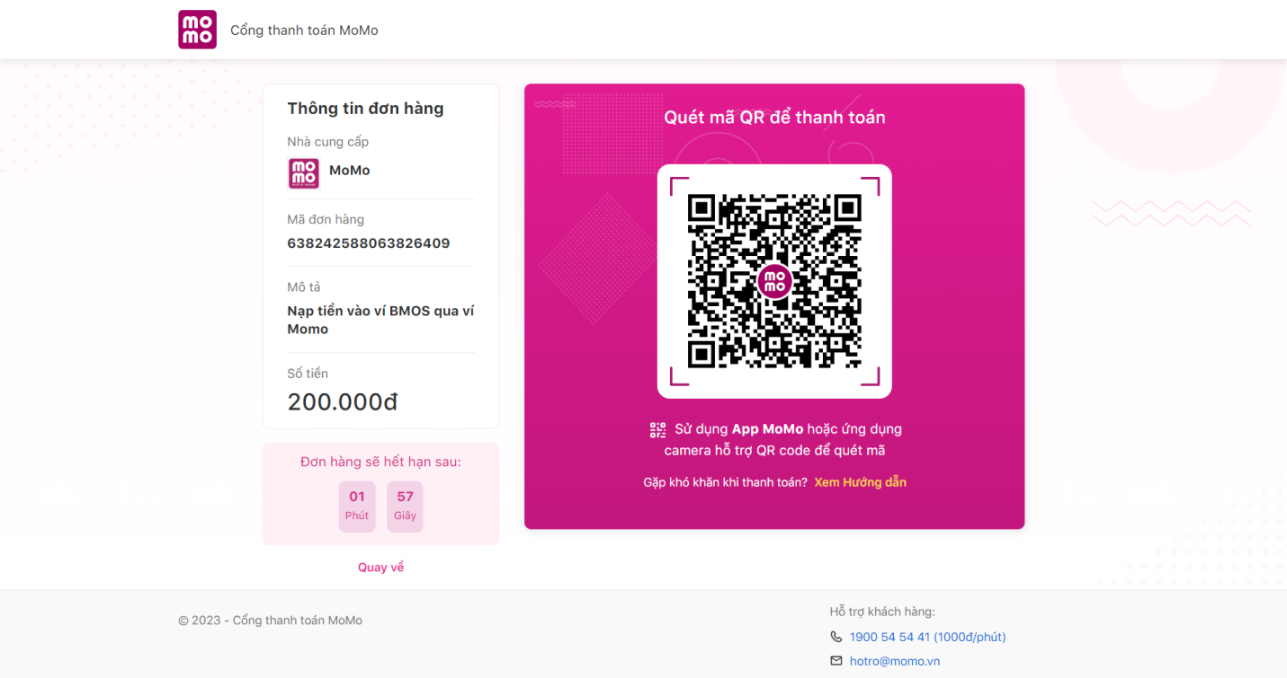

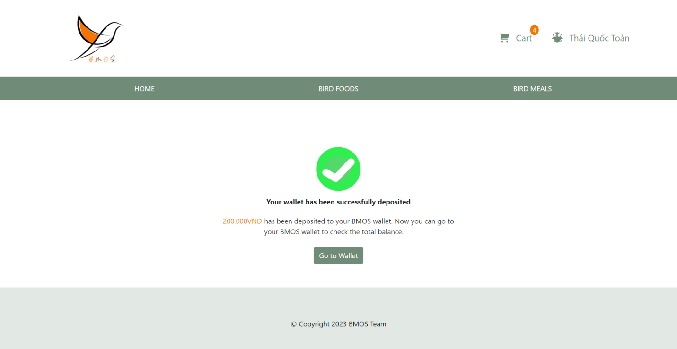

* Customer deposit in BMOS wallet that is failed, so Deposit Failed Result will be shown

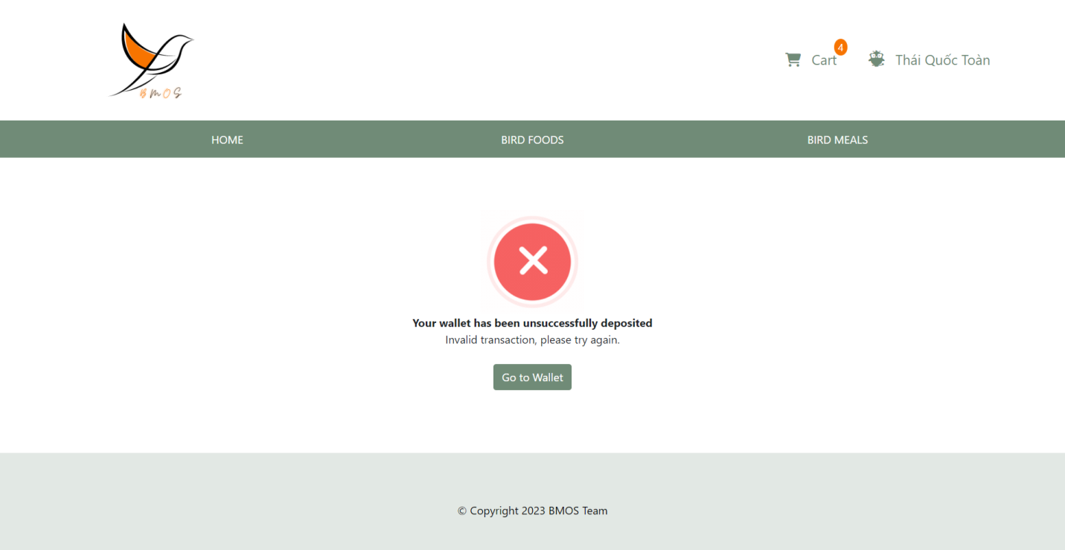

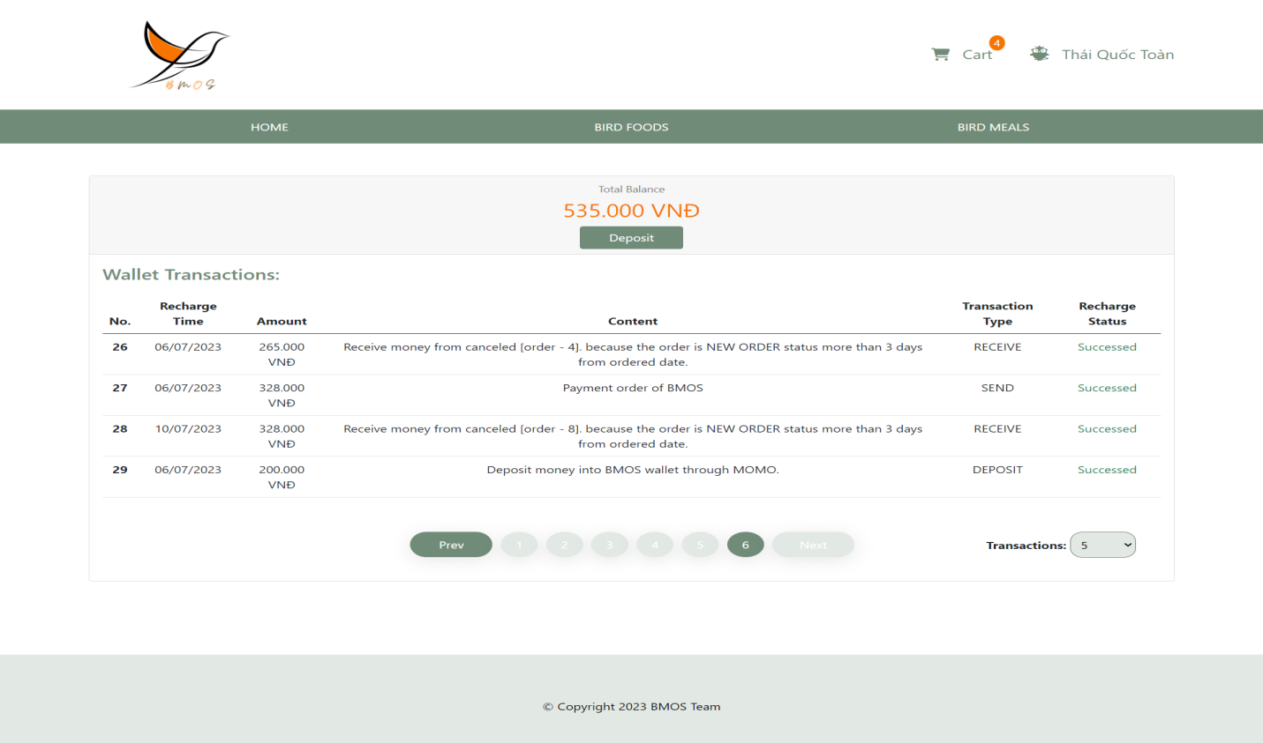

Action 4: Customer will checkout cart and go to the History Orders Page/History Order Page

* If Customer balance is not enough to checkout, “Your account balance is not enough for payment.”

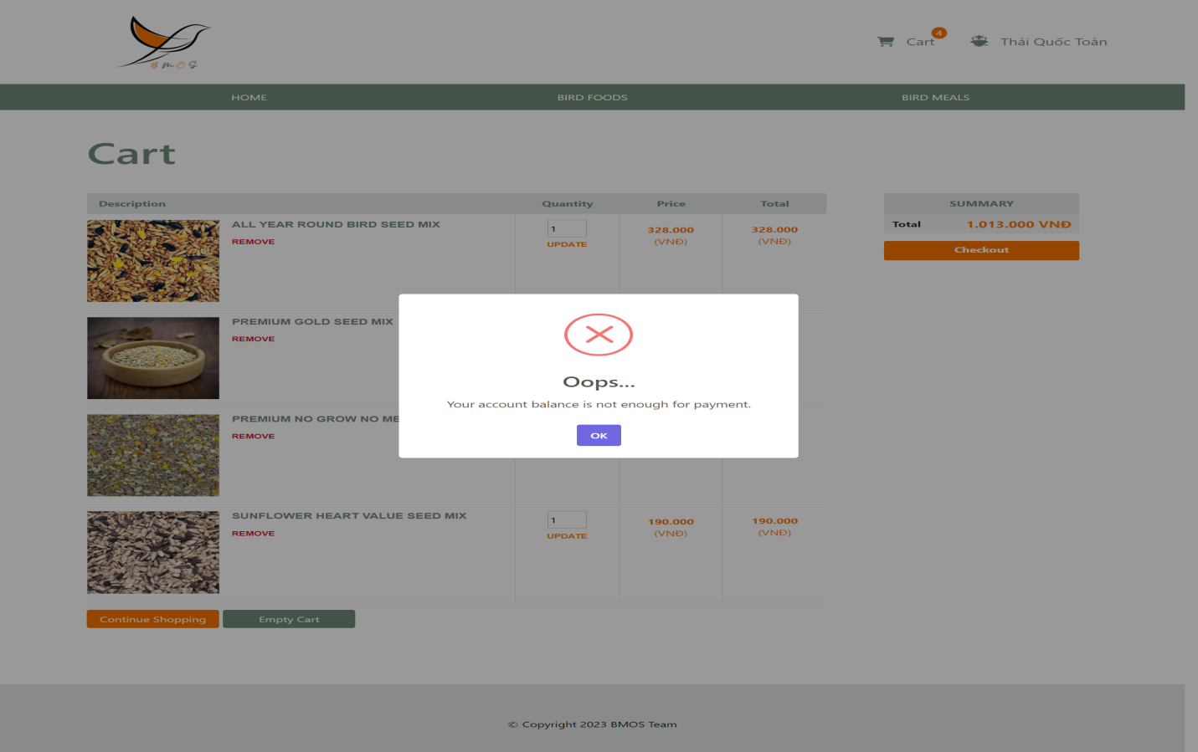

* If Customer checkouts successfully, BMOS web application will show History Orders Page/History Order Page.

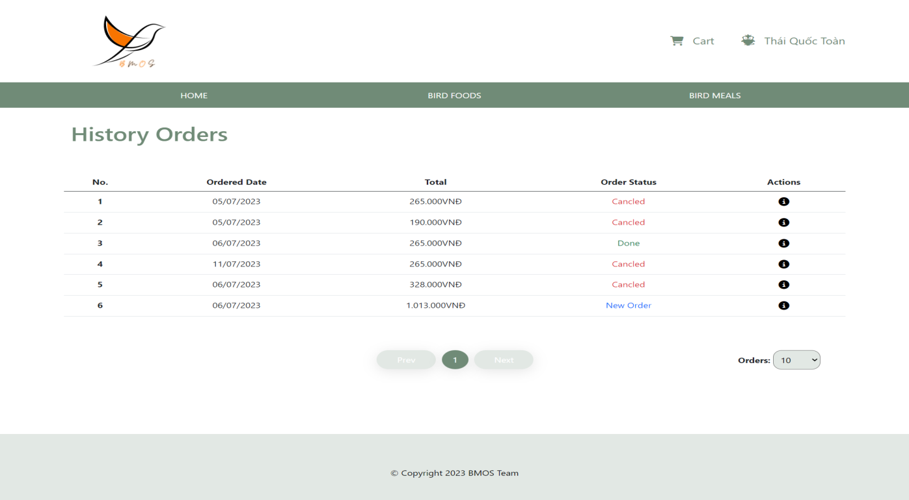

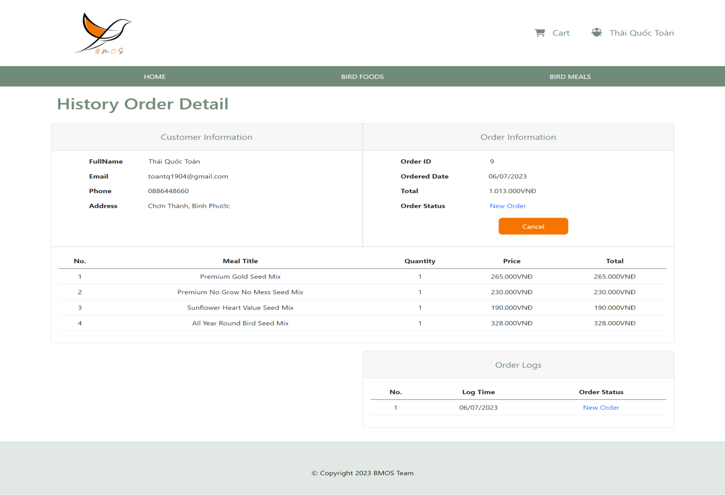

Action 5: Customer can cancel Order when Staff does not have confirmed this order yet. Customer click on [Yes, Cancel it!] button to cancel this order.

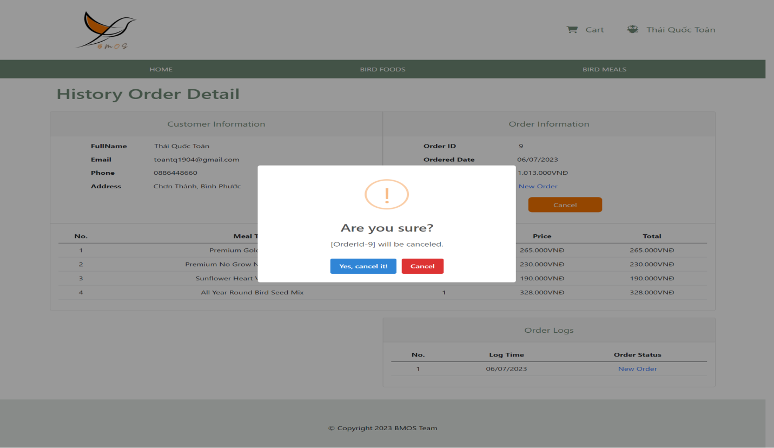

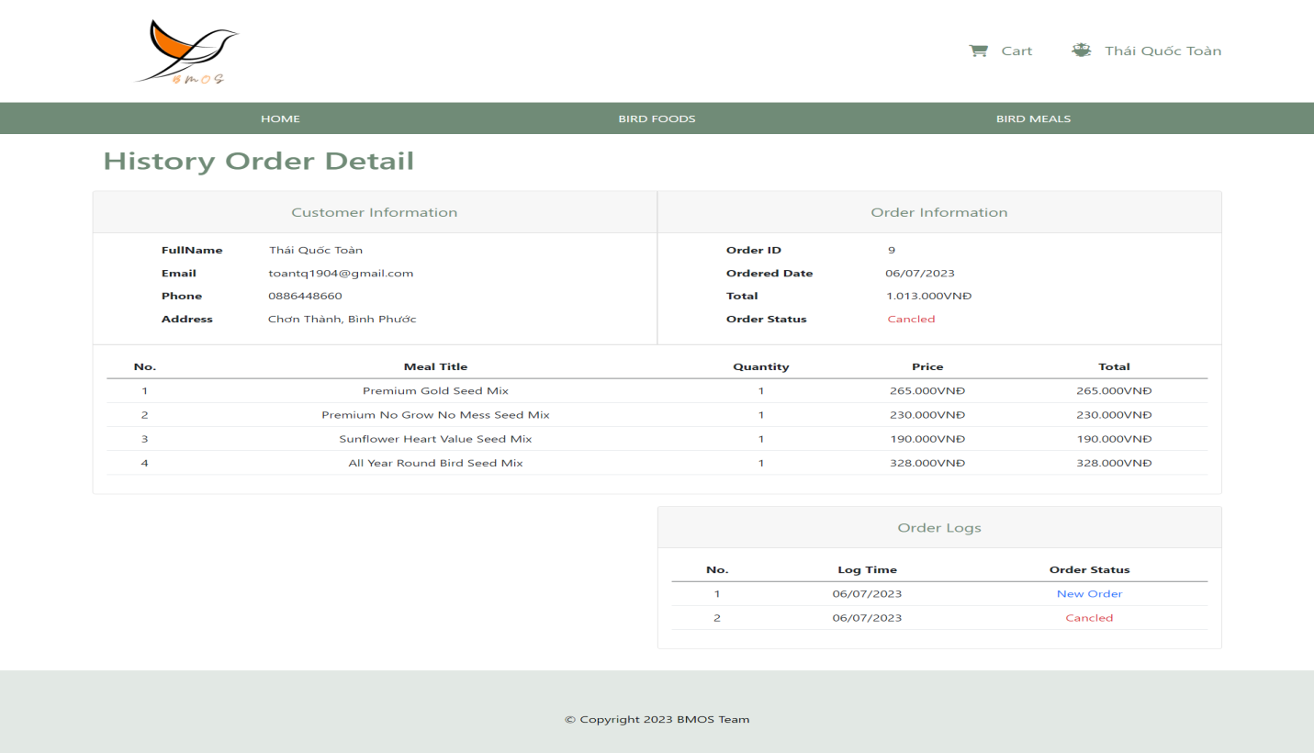

**<Staff> Login Page, Dashboard, Products Page, Product Page, Create Product Page, Update Product Page, Meals Page, Meal Page, Create Meal Page, Update Meal Page, Orders Page, Order Page**

Action 1: Staff type email and password to login. Login Successfully, BMOS web appication will show staff dashboard.

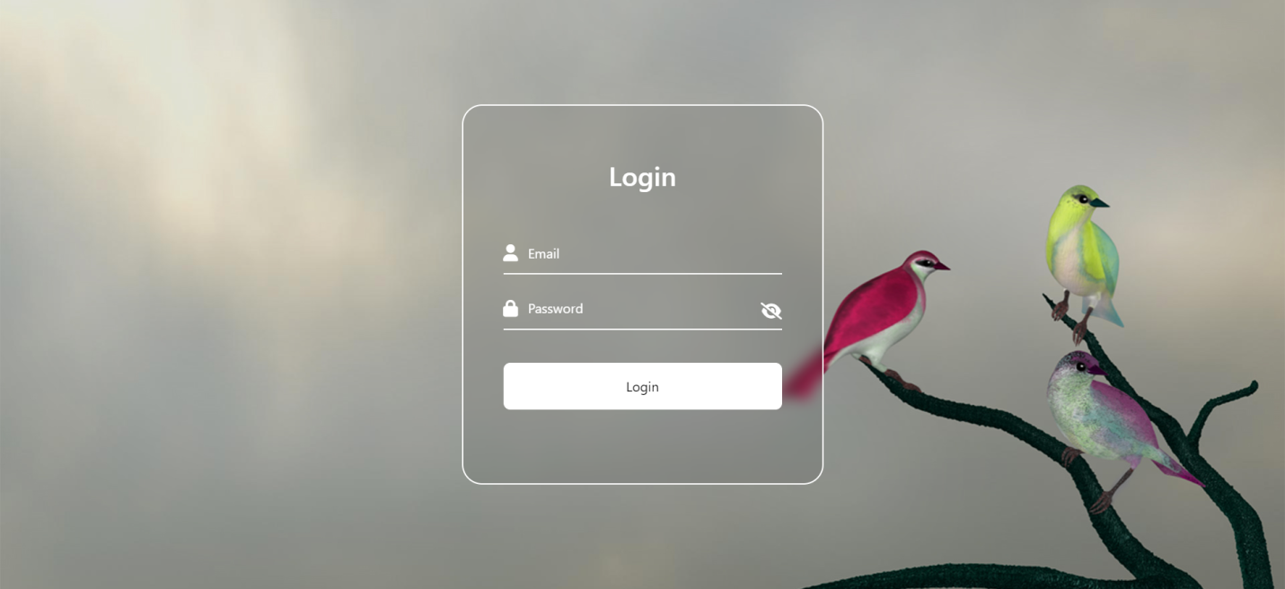

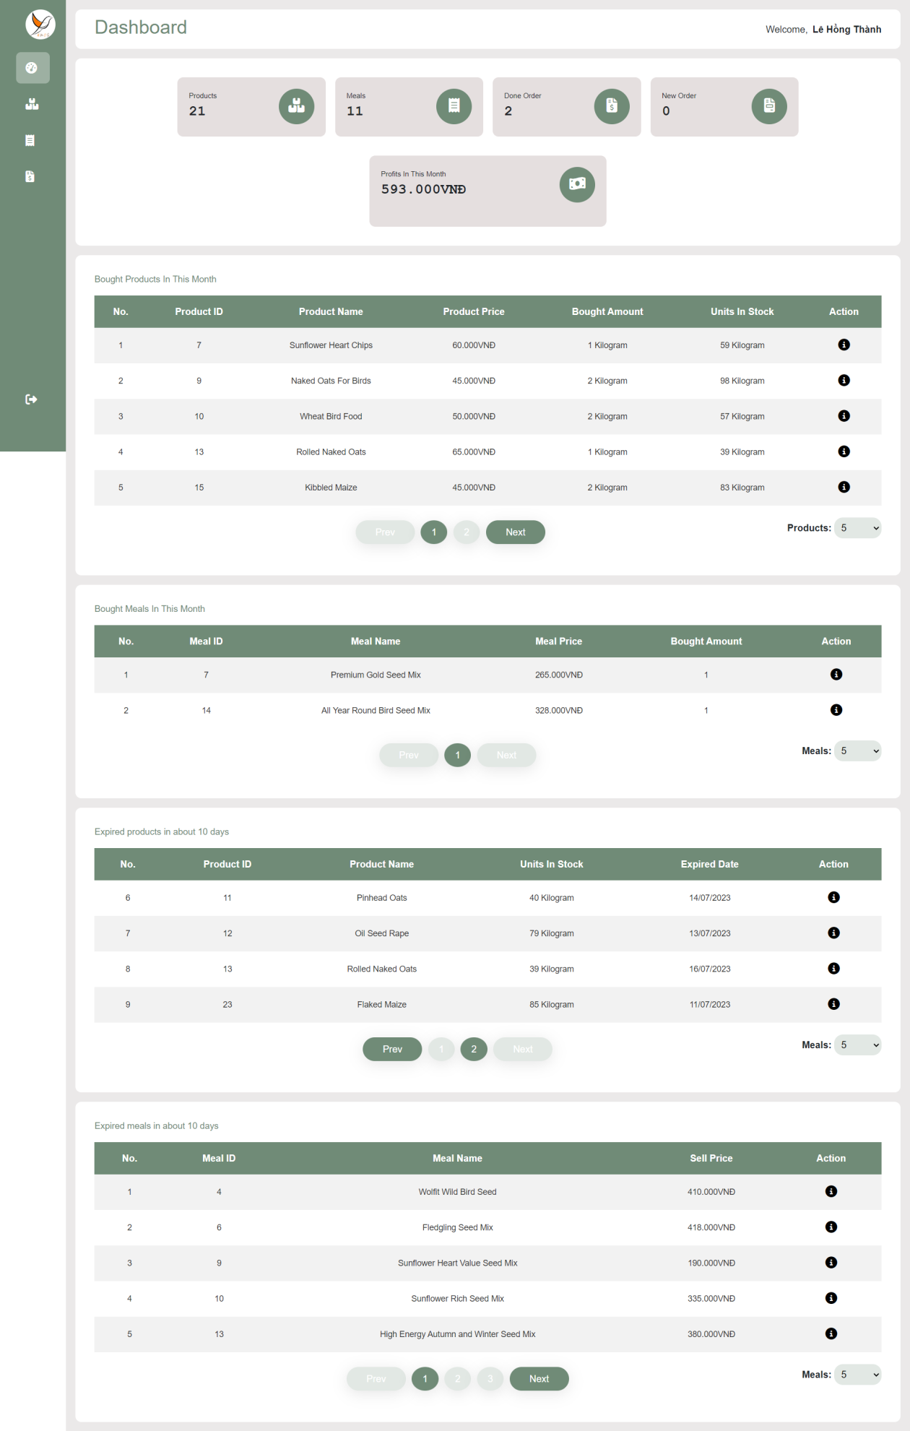Action 2: Staff clicks on [Products] hyperlinl in navBar and view product Detail

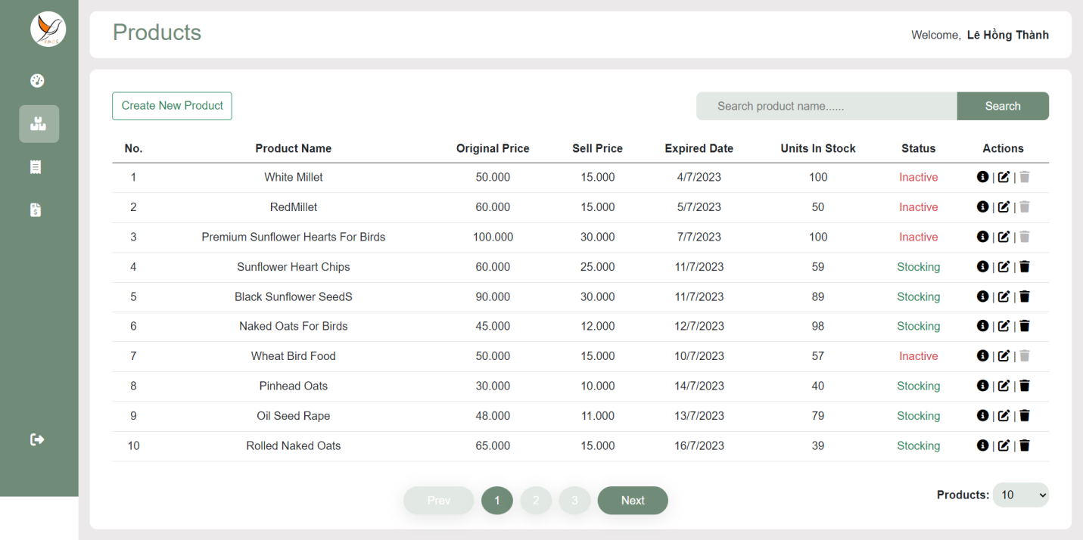

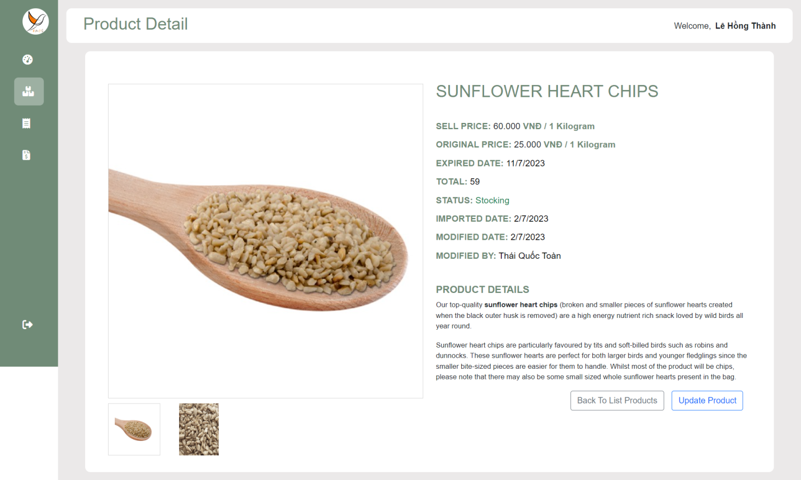

Action 3: Staff clicks on [Update Product] hyperlink to go to Update Product Page.

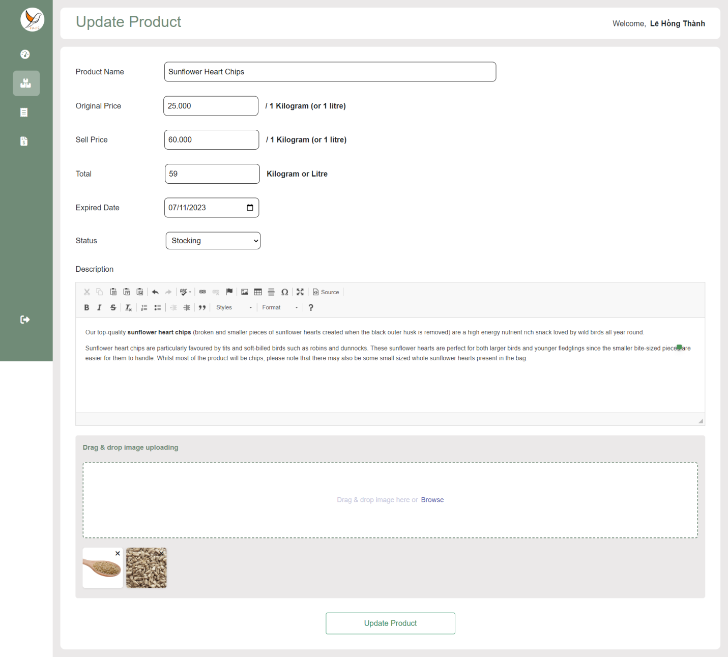

Action 4 : Staff clicks on [Meals] hyperlink in navBar to go to Meals Page and Staff clicks [i] icon to go to Meal Detail Page

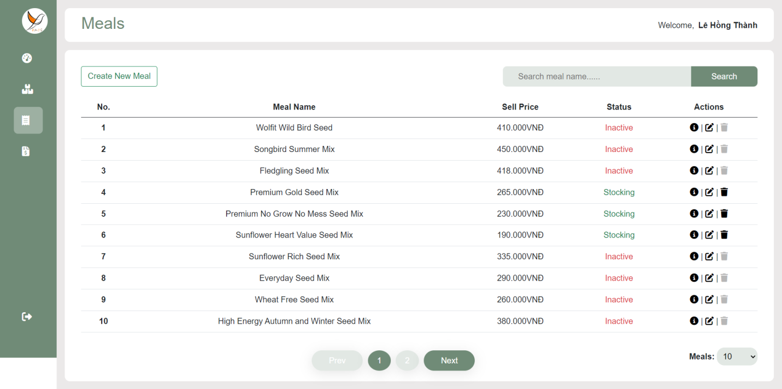

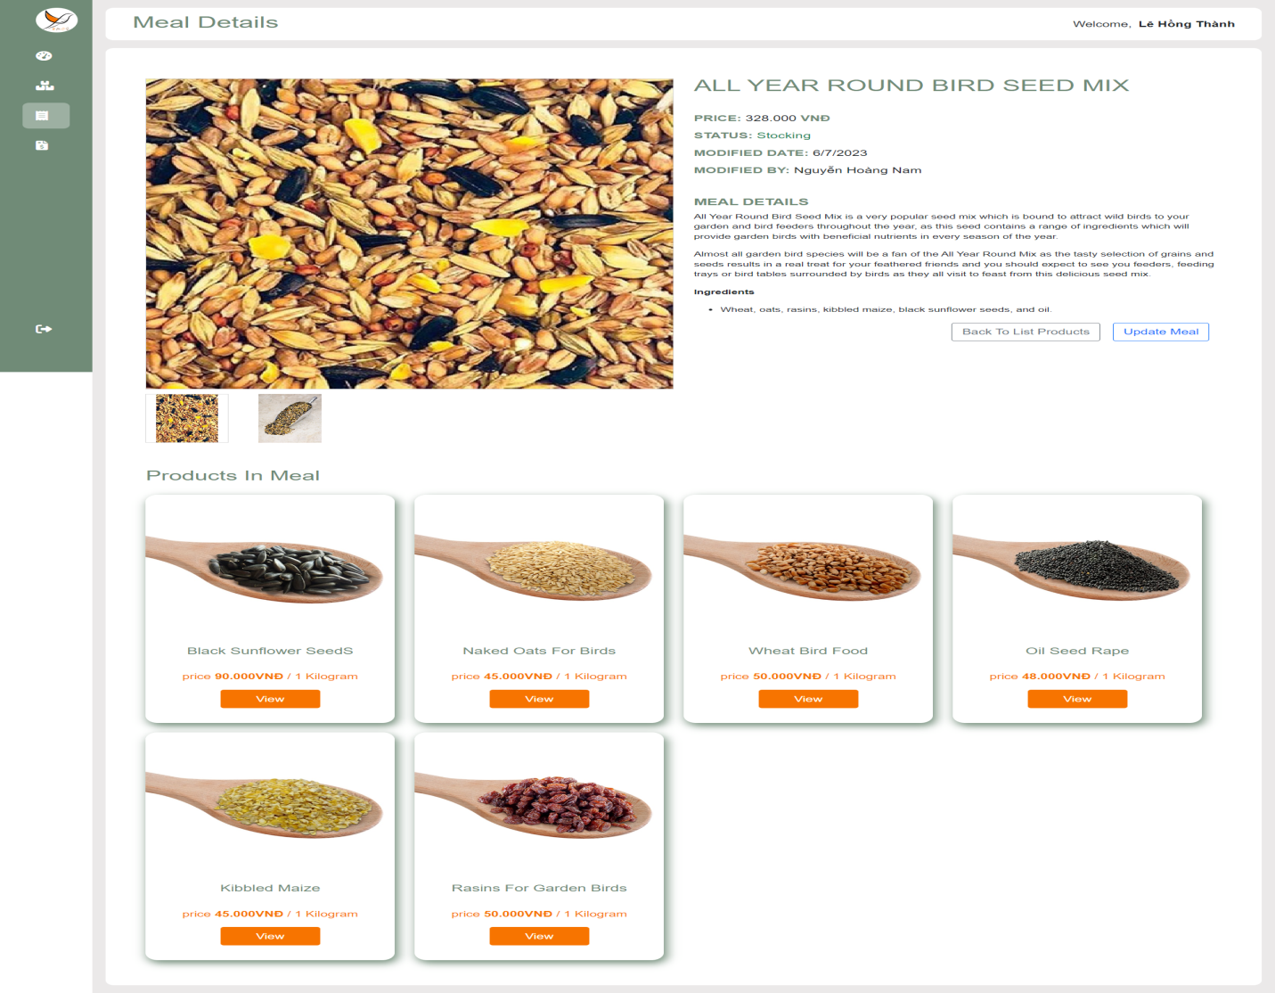

Action 5 : Staff clicks on [Update Meal] hyperlink to go to Update Meal Page.

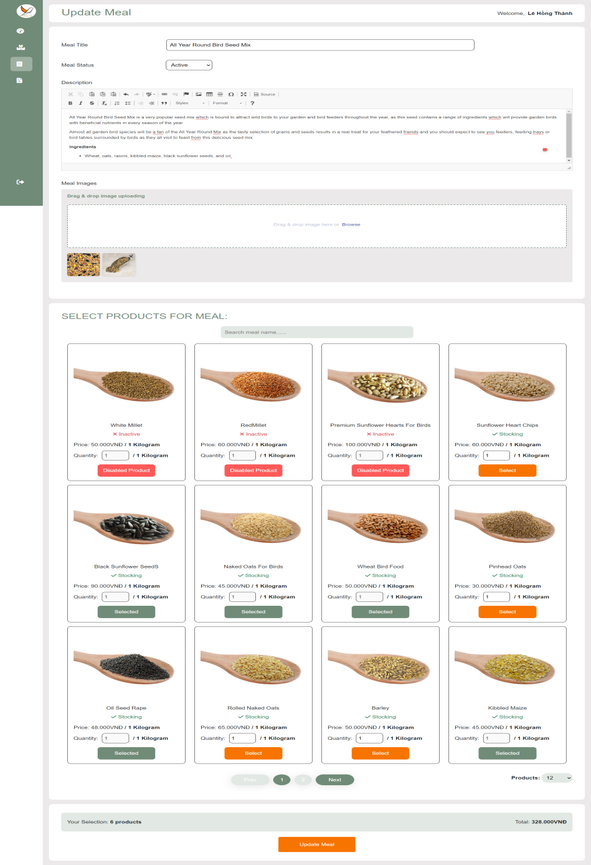

Action 6: Staff clicks on [Orders] hyperlink to go to Orders Page and go to Order Detail Page.

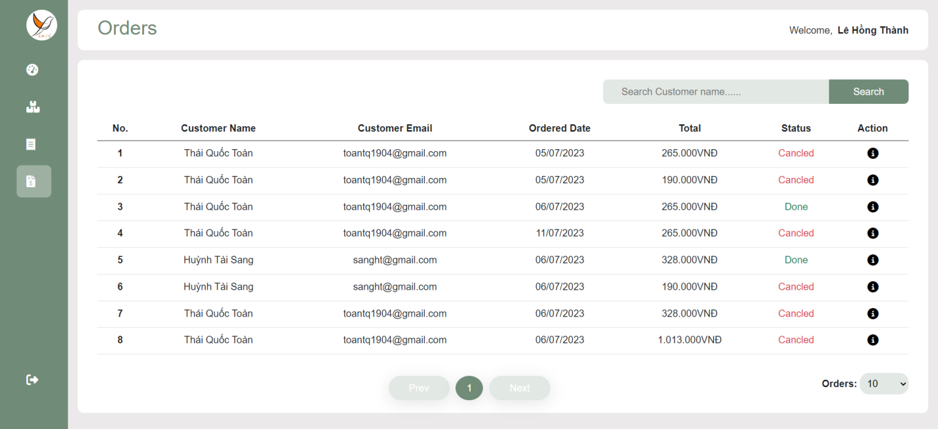

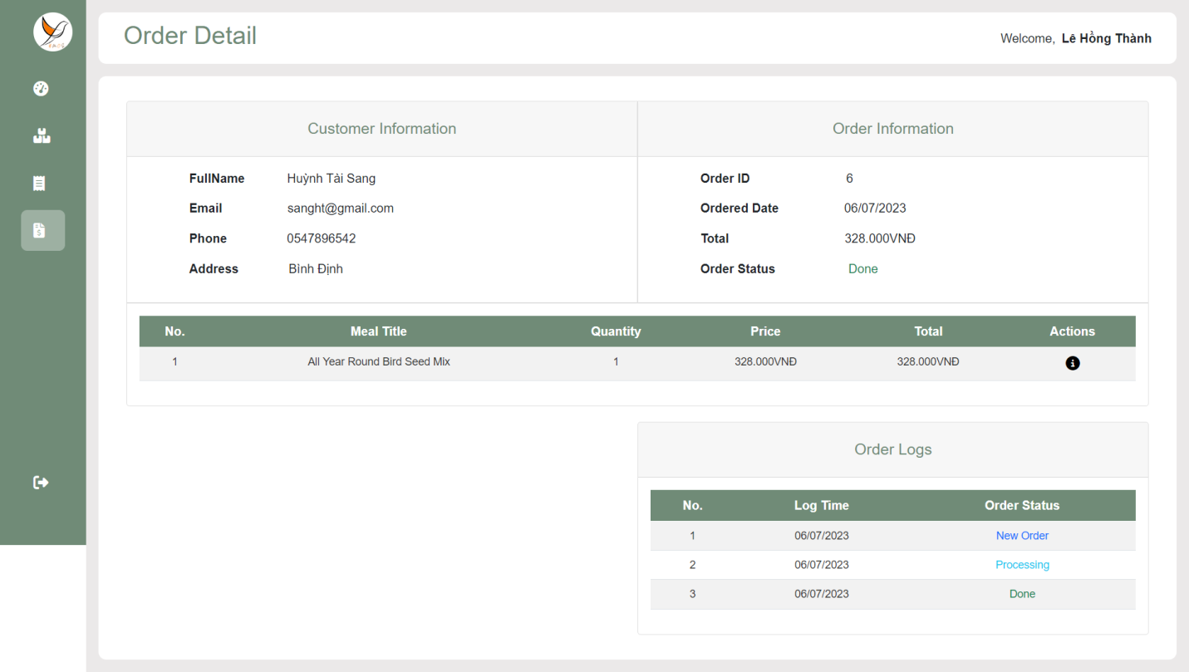

Action 7: Staff click on [Confirm to Processing] button or [Cancel] button.

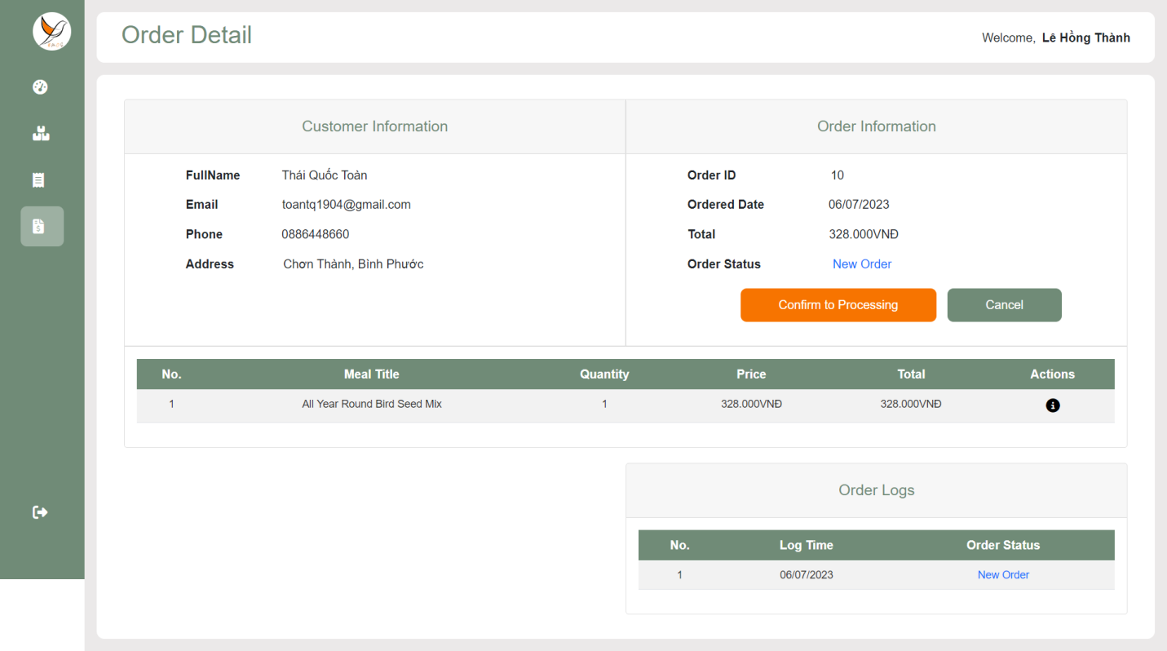

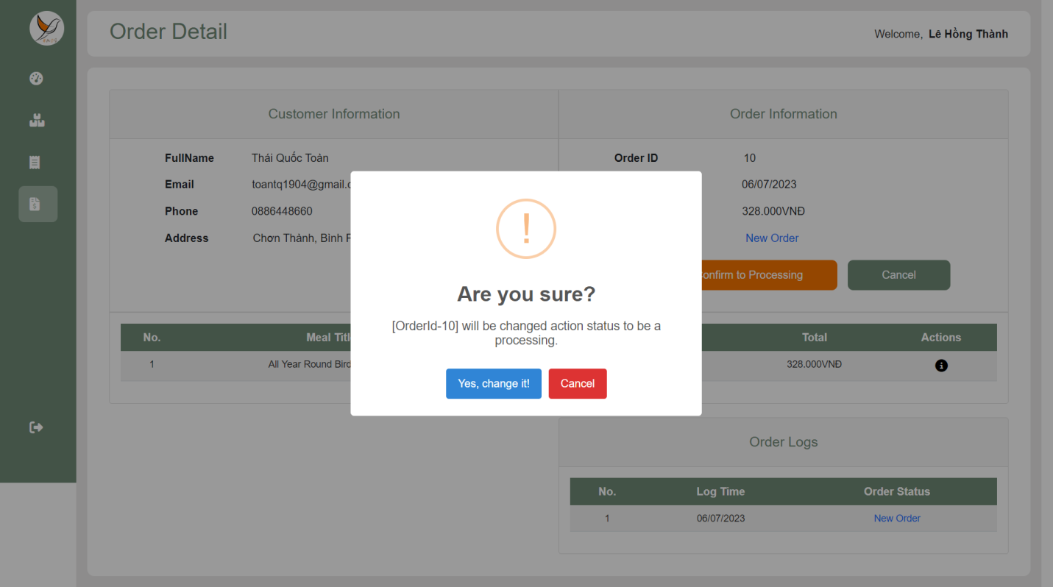

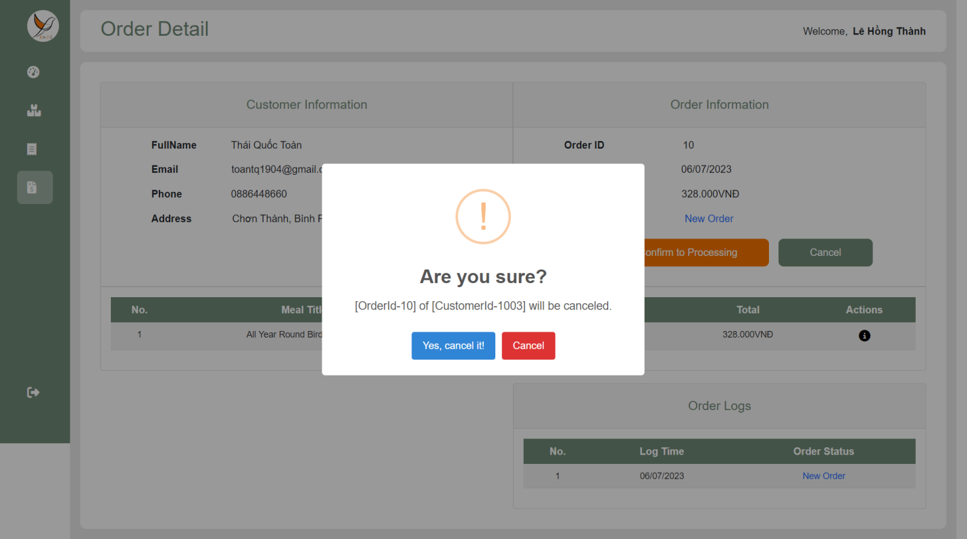

After Staff clicks [Confirm to Processing] and clicks [Yes, change it!]

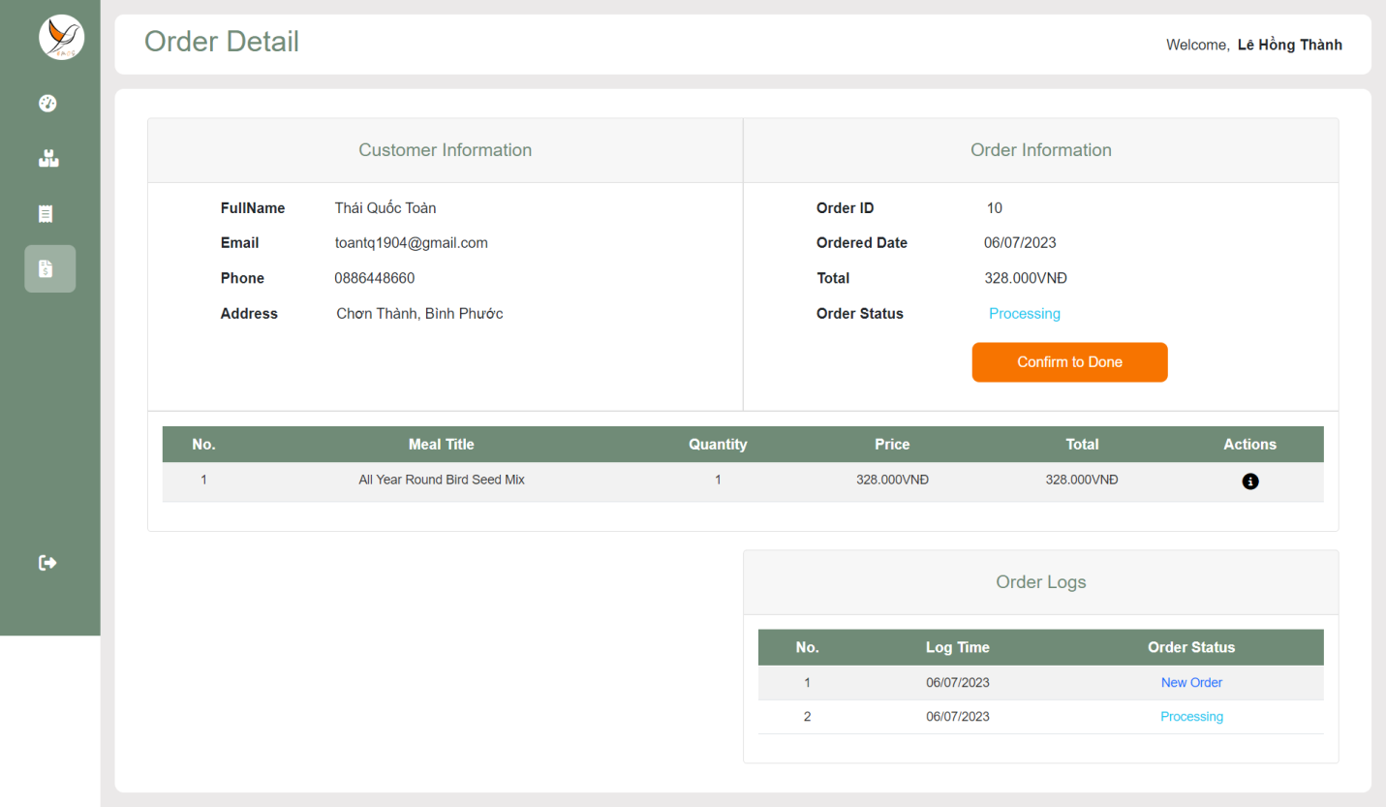

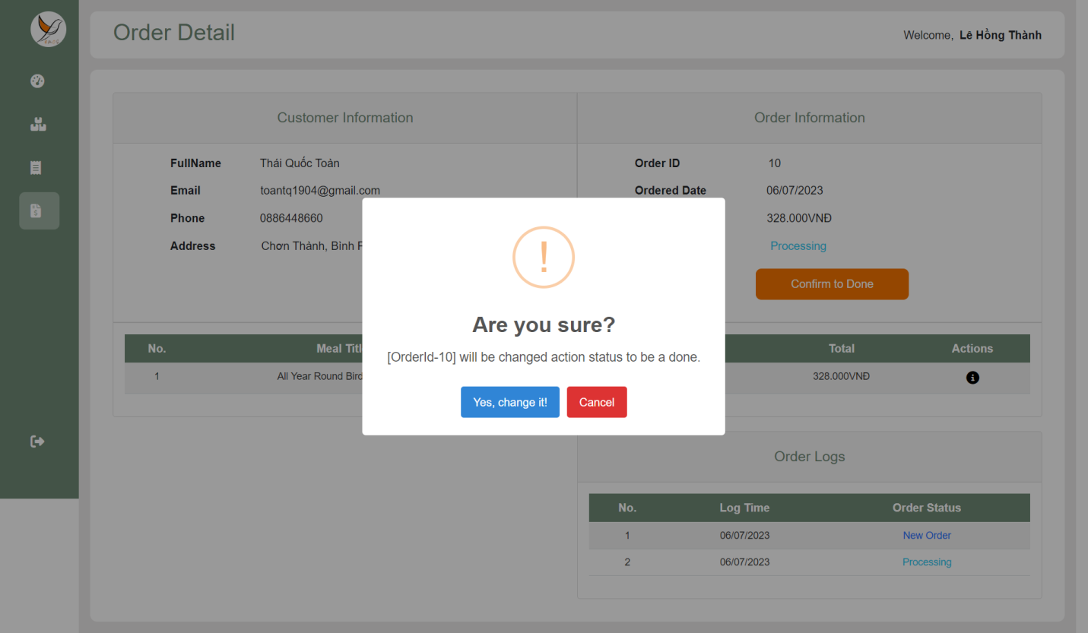

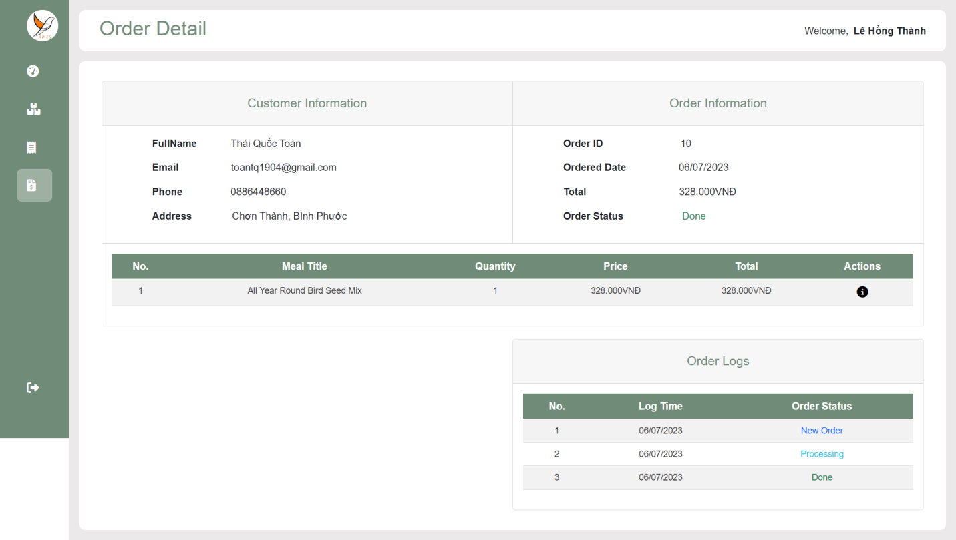

**<Store Owner> Login Page, Dashboard, Customers Page, Customer Page, Staffs Page, Staff Page, Wallet Page**

Action 1: Store Owner Login in the BMOS Application for Store owner and go to dashboard Page.

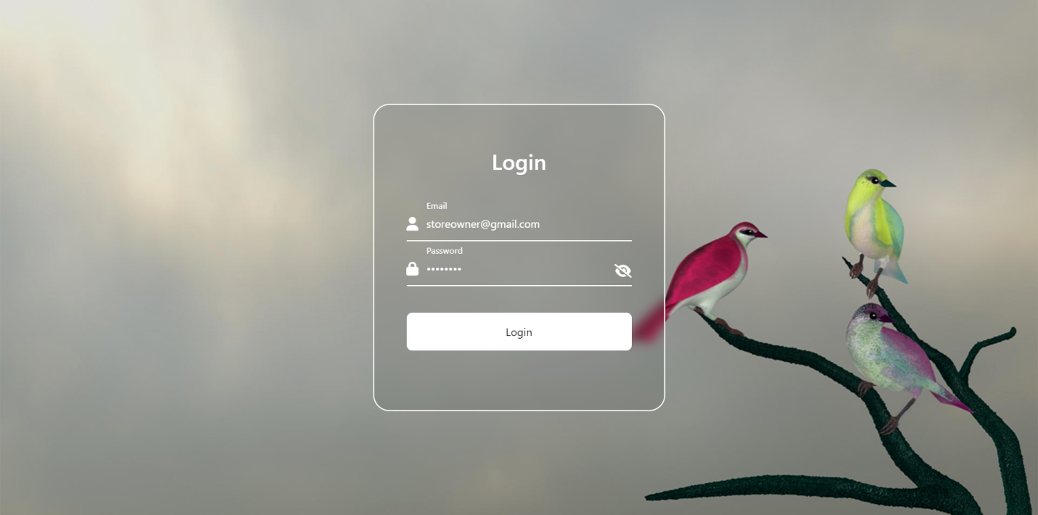

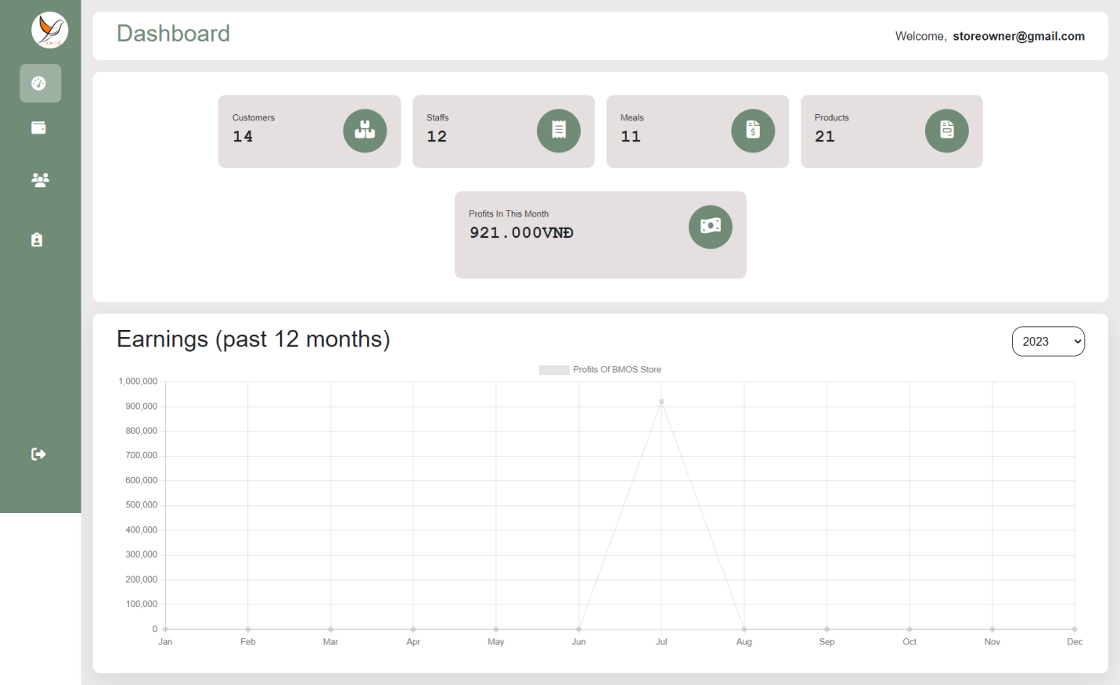

Action 2: Store Owner clicks on [Wallet] hyperlink in navBar to go to Wallet Page.

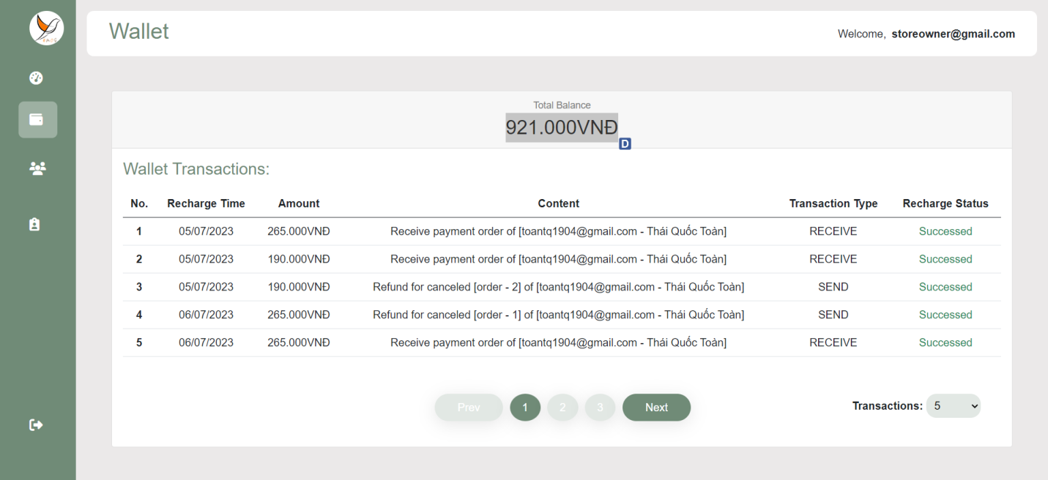

Action 3: Store Owner clicks on [Customers] hyperlink in navBar to go to Customers Page and Customers Details Page

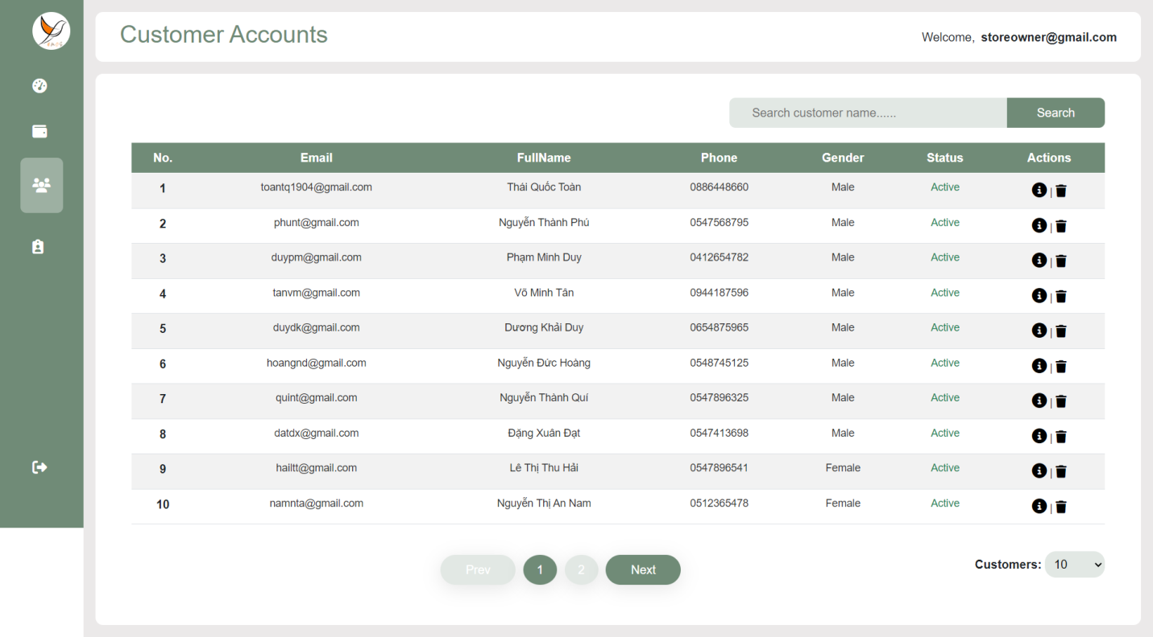

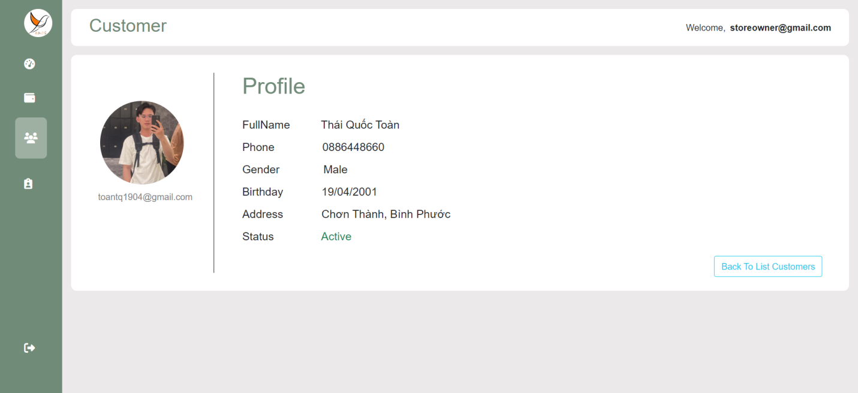

Action 4: Store Owner clicks on [Remove] icon to ban account of customer.

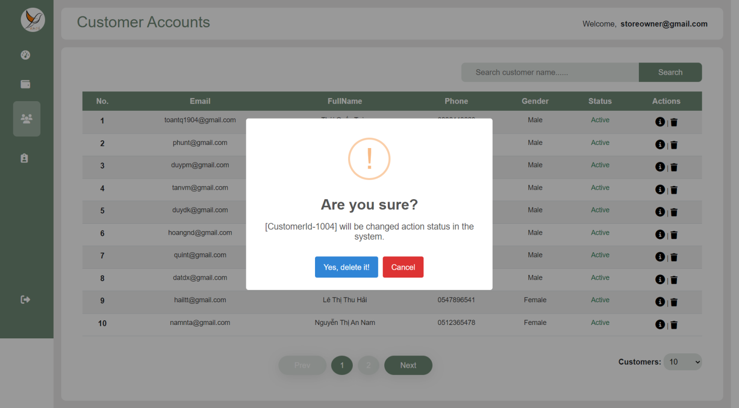

Action 5: Store Owner clicks on [Staffs] hyperlink in navBar to go to Staffs Page, Staff Detail Page

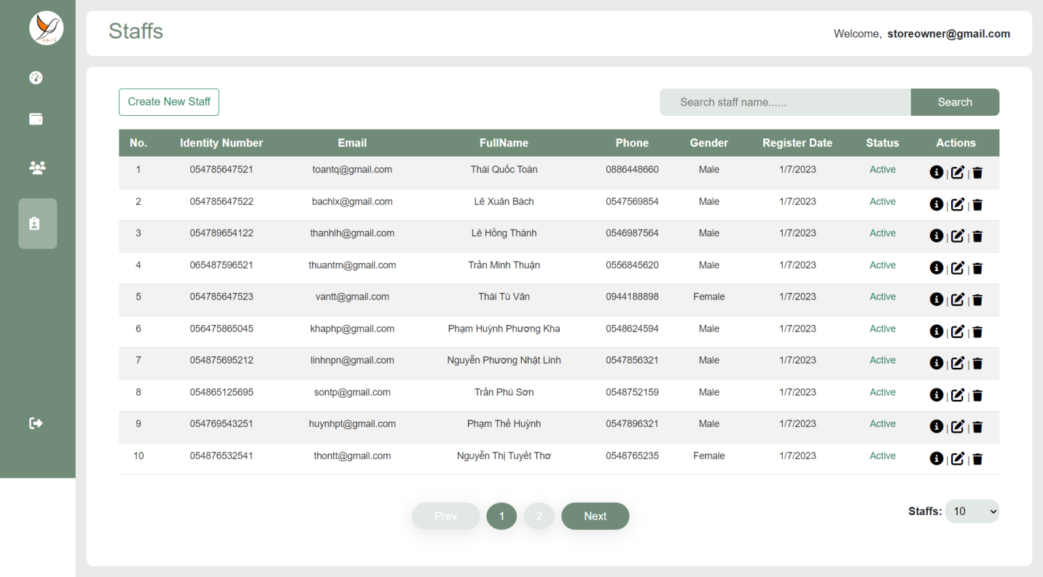

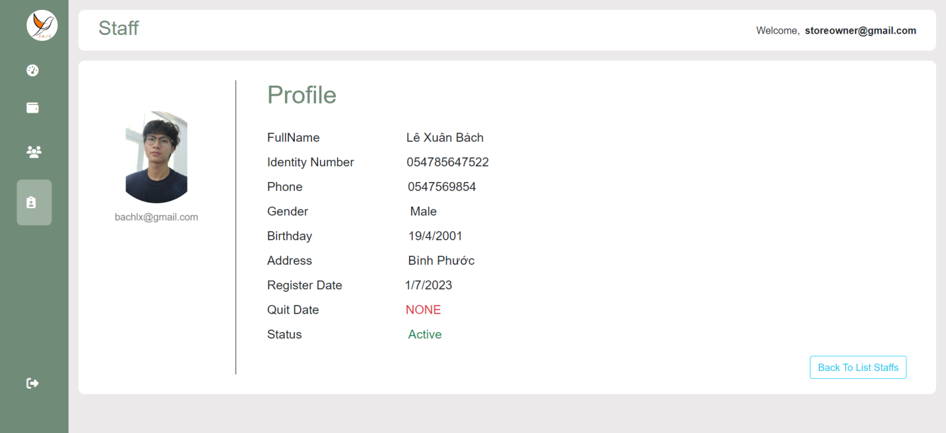

Action 6: Store owner clicks on [Update] icon to go to Update Staff Page.

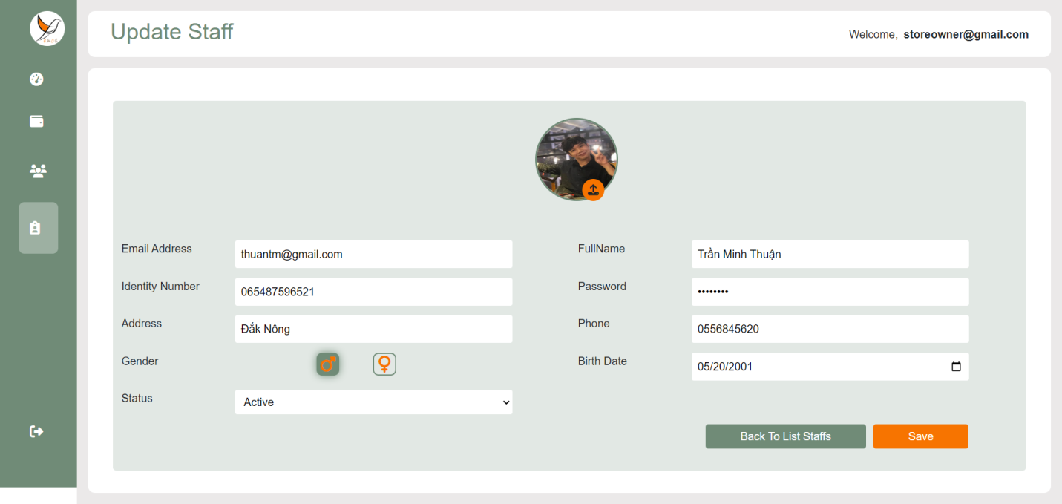

Action 7: Store Ownr clicks on [Delete] icon.

